
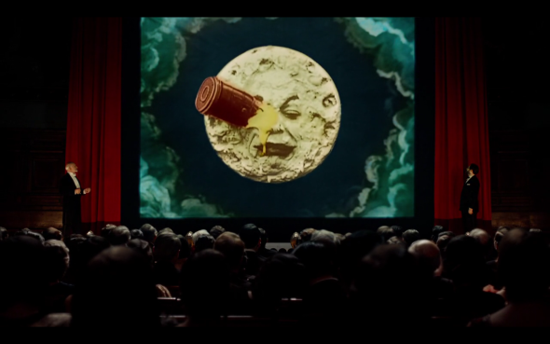
Fantastic film maker reappears into history
Late last night in the French film academy there was a huge party celebrating the life of Georges Melies. They showed some of his movies as part of a celebration. Not all of his movies were destroyed in fact over eighty survived.
Rene Tabard,(a leading member of the French Film academy) discovered he was not dead, when two children (Isabelle Melies and Hugo Cabret)were reading a book about him, and they told him he was not dead then he visited and found out it was true.
Too much of the crowds excitement, Georges Melies then came up and gave an inspirational speech. Rene Tabard stated “He is an inspiration to everyone.” Then his most famous movie a trip to the moon started playing. “I am so happy for him. “Quoted Mama Jean (George’s wife.)
Georges started making his movies in a huge glass house; this is where all the magic happened. The sets, costumes and movies were made. After the Great War everyone’s tastes had changed (because everyone had experienced it already for themselves) and no one liked his movies, so he burnt everything. He didn’t have much money so he sold his movies which were turned into boot heels.
They could only show the movies, when Hugo Cabret Isabelle Melies and Eteinne Pruchon (A leading member of the French Film Academy)
By Thomas Gowland
Parisiennes watching a trip to the moon.

Searched for the lost movies for six months and over eighty came back.
There would be no cinematic special effects if it wasn’t for the cinema legend Georges Melies. He hopes that this will inspire a new generation of film makers and that people will carry on using cinematic special effects. Georges is going to continue on with a quiet life and he is not going to return to film making.

