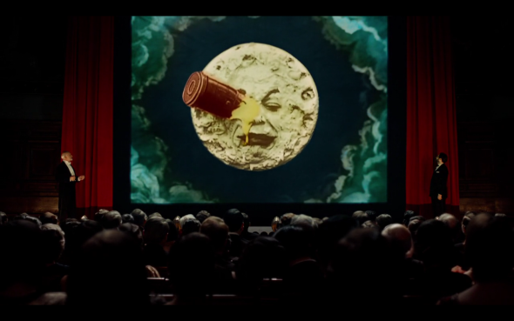

A Trip to the moon. FFA.
Isabelle Melies found out more about Georges. In the library is where all of the films from the first to the last are held. The French Film Academy is in Paris, France. On the 21st of July 1931 at 8pm the gala began, showing 80/500 of his movies, pictures and magic tricks to remind the Parisians of him. Run by Rene Tabard, according to Isabelle Melies, it was a success. After the gala had ended they travelled to a restaurant to celebrate the cinema legend.
The Parisians are overjoyed to see miraculous Melies again. His appearance had an amazing effect on the people of Paris. We all hope that after all this the wondrous wizard will begin to make movies again.
Last night at 8pm it was discovered that cinematic movie star George Melies was alive. Inside of the French Film Academy (FFA) Georges was revelled on stage with an incredible audience of Parisians. This was held to celebrate all of his movies.
George Melies was an incredible wizard, who was a film director producer and developer. His most famous film was called A Trip to the Moon. This was about some astronauts who travelled to the moon and met aliens. The miraculous movie star was the first to use special effects in a film. After being inspired by the Lumier Brothers he began to create his magic tricks on camera. Before the war, he burned all of his set his actors had left to fight. After the war had ended, everyone thought Melies was dead but he actually was disguised behind the counter of a toy booth in a train station. Now we know he is alive.
A young boy named Hugo Cabret, the godson of Melies, said “I’m overjoyed that Papa George has finally shown everyone who he really is.” Jeanne Melies, the wife of George, said that hes been hiding from himself for years stuck behind the toy booth, not expressing his feelings, but now he can.
The FFA was where Hugo Cabret accompanied by Rene Tabard and Isabelle
The resurrection of miraculous Melies

