

Melies’ movies are back!

Monday 16th December 1932

Last night, the French Film Academy held a celebration for the life and work of cinema legend Georges Melies. He left the crowd in delighted disbelief when his lost movies were shown for the first time in twenty years. However, pioneering illusionist Georges Melies was believed to be deceased after mysteriously disappearing after World War 1.
Melies created over 500 movies; sadly many got destroyed during the Great War Strangely he was found working at a toy booth at a train station.
Georges Melies’ famous film a trip to the moon
The celebration was introduced by Film Academy member, Rene Tabard, who showed over a staggering 50 of Georges Melies films. Known for his cinematic special effects, Melies was greeted by the clapping and cheering of the crowd. One lady stated, “after thinking he was dead for so long, I can’t believe he is actually here.”
Perhaps the most incredible moment was when Melies introduced his audience as Pirates, mermaids, kings and queens. Instead of lady’s I silk dresses and men in top hats.
Without the work of Rene Tabard, Etienne Pruchon ( another film academy member) Isabelle Melies ( Georges Melies’ Granddaughter) and a young boy called Hugo Cabrait ) the celebration wouldn’t have been possible. They travelled around the world finding lots of Georges Melies’films in

By Emily Lyndon
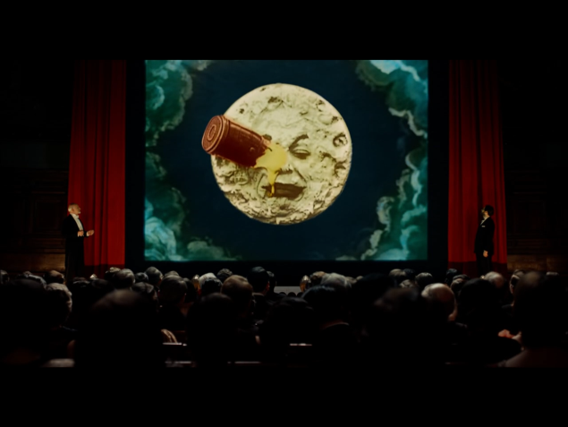

Private collections, Barns and catacombs.
Georges Melies is an inspiration to all said Rene Tabard. He has created the next generation of movies and will bring light to the world wherever he goes.

