
Amazing Achievemens of Magical Melies
22nd August 1931

Last night, the wonderous George Melies returned to the stage after many months of a suspected disapperance. A celebration ceromony was held at the french film acadamy where the rediscovered work of Georges was presented to the wide world.

Hundreds of people sat in rows and rows in front of the projecter. When Melies became present, he gave a short speech regarding the people, “Tonight, I do not see you as Bankers, Clerks, Mermaids, Kings and Queens. I address you tonight as you truly are. A french film acadamy member – Rene Tabard- held the last few films existing by georges melies.

This inspiring man lost all his hope and his career after the world war was declared. Many of his films were left destroyed among the awful damage the Great War had caused. However, few were saved and shown at the touching celebration. The curtains were drawn and you could see an emotional sensation fill the atmophere as the film began. Rounds of applauses showered onto Melies and the overflowing fans cheered. Georges said to us that he had never felt so happy in his life. A young boy in the crowd quoted, “ being here tonight is like a dream come true. I have never smiled so much in my life. Dreams really are made in theatres!”
Without the work of Rene Tabard, Etienne Pruchon (a student at the Academy who

By Ruby Hall
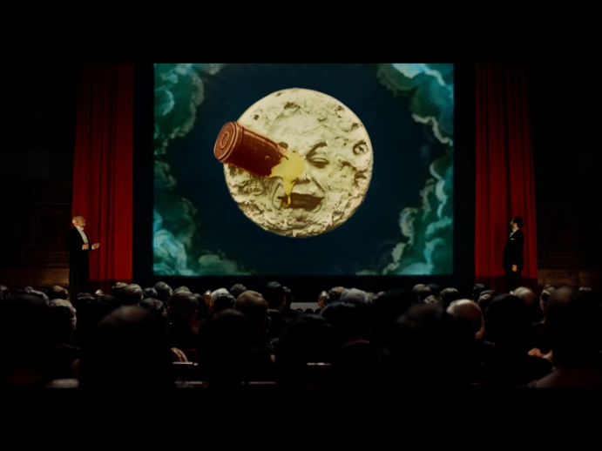
The crowds and an overflow of fans were entrieged about melies’ magical movies.

thought lots about Melies), Isabelle Melies (Georges god daughter) and Hugo Cabret, none of his films would be in existance. Searches have taken place to find more of melies magical movies so they can be enjoyed once again.

In the magical halls of the theatre, dreams were created. Genorations will be inspired by this wonderful pioneering film maker. Forever he will be known as the remarkable, the creative, the pioneering movie star – Georges Melies. He has a fantastic story to tell and those stories will be remembered for many years to come.

