
Melies Magical Movies

Friday 20th August 1931

Yesterday evening, Georges Melies, who was a magical movie maker, was rediscovered. He was to be dead along with many of his films in the Great War, when Hugo Cabret (a young orphan) Isabelle Melies (Georges Melies God Daughter )Etienne Pruchon(a student from the French Film Academy) and Rene Tabard ( a worker at the French Film Academy did not want to stop finding out about Georges past.
The wonderful movie theatre where Georges made dreams come true was in Paris. Rene Tabard invited many people to come and see Georges Melies. That night he stated “I don’t see you as clerks, bankers and housewives. I address you as you truly are: wizards, mermaids, travellers, adventurers and magicians. You are the true dreamers.”
Hugo Cabret was close to Georges. After enjoying seeing a small fraction of his remade films he said “Georges is a wonderful person. He is a true dream maker and his films are amazing.”
After Georges films got destroyed, he worked from a toy booth in a Paris train station. He created over 500 films and 80 got made in colour.
Reporters were told that the purpose of the evening was to assure that people knew about his life story. “I loved Papa Georges films. He really does make dreams come

By Lara Chadda

true. I never knew about his past. Now I do. It was making people live in their biggest dreams.” Isabelle Melies exclaimed.
The audience enjoyed his films very much and without Rene Tabard, his films would not be seen ever again and many people would be missing out on lots of his movies.
In conclusion, we are so glad that Georges Melies is still alive. His films have been found and people enjoy them very much. Theatres are overflowing to see the magic of Melies. Our dreams have come true in his remarkable movies.

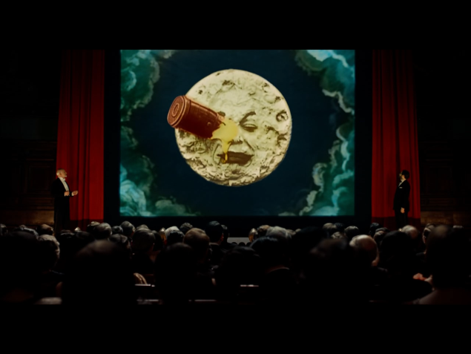
The audience were watching his most famous film – A Trip to The Moon

