
Thursday 19th December 1931
The magical Méliès is back!

Last night, Paris was held at a standstill and jaws dropped to the ground as the pioneering illusionist extraordinaire George Méliès makes his first appearance after he was believed to be deceased. The life and work of this movie magician was showcased at the French Film Academy.
This iconic man was thought to be dead! It was the logic because most movie/film makers had died in the Great War. Bizarrely, he has been right under our noses this whole entire time as an old toy booth owner!
We wouldn’t have even known he was still alive but thanks to Rene Tabard (The owner of the film academy and the host of this event), Isabelle Méliès (The goddaughter of the film director George Méliès) and Hugo Cabret (an orphan at the local train station who was adopted by George).
Many of his extraordinary films were showcased that night. Over 50 of his films were recovered over time and were presented to the audience, sat on their seats with suspense. Excitement filled the room as all of his recovered films long and short was projected onto the large board.
He addressed everyone as different fantasy figures. It made you feel like you were included. We had come here to watch the films but when you’re in a dark room with a film playing didn’t make you feel like you were watching the film but it made you feel like you were included. It made you feel like you were with the king of the sea or riding a gold chariot through the sky.
We decided to ask some of the guests who witnessed the magic of the movies that night. I was there last night to report that his films were showcased for the first time In 4 years. They were believed to all be lost until now. One of them replied with “It was amazing seeing the magic happen in front of me. The colourful images danced across the screen saying silent words. Muted on the screen” Another one said “pony’s and rainbows and magic and even more magic! This was one of my most favourite movie showcasing in my life!” As you can see, lots of people enjoyed this once in a lifetime experience.
Therefore, this event was one to be remembered. Now, Georges is at his home enjoying his last years as a family. This is probably the last time we would see him make a film. Who knows? Maybe he’ll start making movies again.
This is Tinaye Musiza reporting to you from here to you.
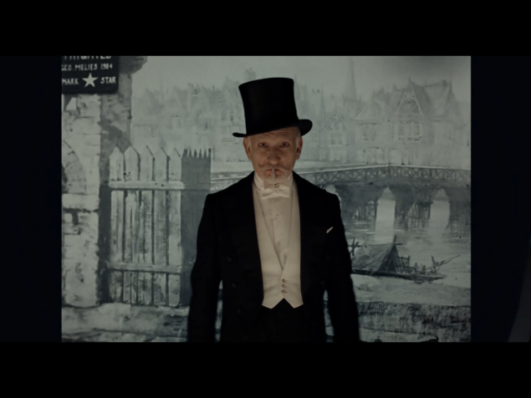
George Méliès

