GODS The ancient Greeks had many gods and goddesses like Zeus the King, Athena goddess of wisdom, Hades of death and Ares god of war.

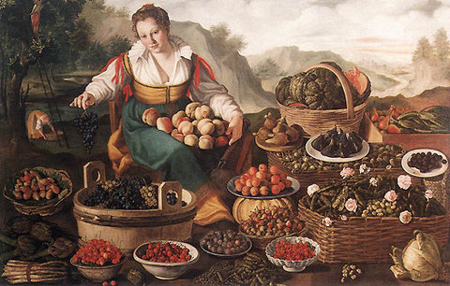
FOOD
the ancient Greeks ate olives, grapes, figs and wheat and kept goats, for milk and cheese. They ate lots of bread, beans.
CITYS
The most important cities in mainland Greece were Mycenae, Tiryns, Pylos, and Thebes. Other major cities that were not quite as important included Orchomenos, Athens, Gla, and Lolkos. The capital today is still Athens.

MYTHS
Persephone and Hades, Orpheus and Eurydice, Theseus and the Minotaur, King Midas and the golden touch, Perseus and the Gorgon Medusa,
- Odysseus and the Trojan Horse. are all myths. There are many different versions of these. Some myths have been made into paintings, films and books.

OLIMPICS
The Olympics was a sporting event heled every 4 years and is still around today. At first the only event was a race that a baker called Curibous won. Soon the Greeks added more events like the javelin, long jump, discus and boxing, we still have some of these events nowadays.
CLOTHS
Greek woman wore long tunics called a chitoe. This has made from a piece of cotton or linen. Over this, they wore a cloak draped from her shoulders, called a himation. Young men wore short tunics, while older men preferred long ones. Slaves often wore just a strip of cloth called a loincloth.

ENGLISH FROM GREEK Here are some ancient Greek words we use today!
octo = eight = octopus
deca = ten = decade
gramma = writing = grammar
anti = against = antibullying
phone = sound = telephone
tele = far away = telephone
As you can see, the English language has many parts of Greek vocabulary in the words we use today.

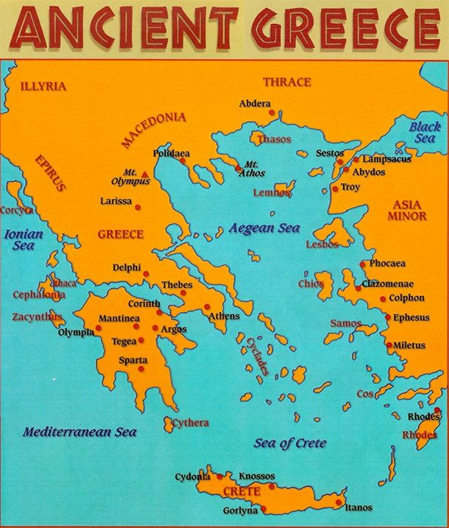

The ancient Greece empire was amazingly big, the capital is surrounded by silver.

