XENIA, GODDESS OF Time!
by Aurelia Noyce

Once in ancient Greece, in the ruling time of King Latinized Pisistratus,
there was a girl called Xenia and she was the daughter of Aphrodite, but she didn’t know that. The thing is she's mortal because, like with Hercules, Hades made her drink the mortal making potion, but she kept her powers.

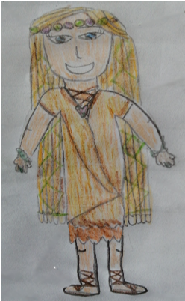
Xenia was beautiful, she had ocean blue eyes, golden braided hair and a heart necklace. Her clothes were made of linen sandy rags, on her feet were worn-down leather sandals, a lavender crown was upon her head at all times and stone bracelets and rings showered her hands and fingers. She lived in a small village and was bullied for being so plain ...WEIRD!

She was very different to the other girls in her village, so she visited Zeus King of Gods to find out why loads of strange things kept on happening. For example, last week her mum was making 2 loafs of bread an hour then, Xenia somehow sped it up and, suddenly, there was 15 loafs a minute. Zeus told her that she was his granddaughter.

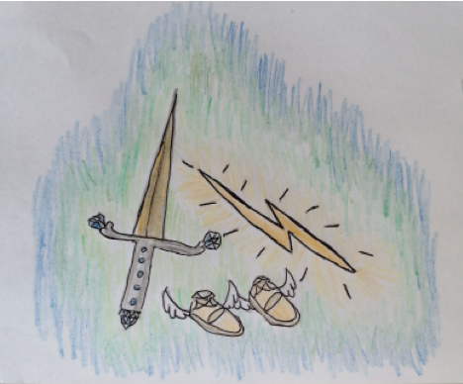
To rebecome the immortal goddess of time she had to recite the ritual with the monster, Menosar’s, magical immortal making mane. Many had tried but only one succeeded, it was Menosar's hair (or rather mane) dresser. Xenia was given an unbreakable sword by Athena, pair of winged shoes from messenger god Hermes and a single lightning bolt from "Grandad" Zeus.

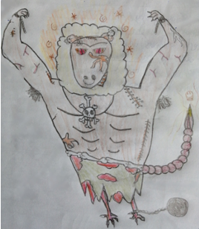
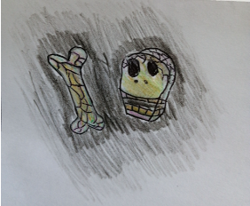
using the winged sandals Xenia flew over seas to reach the cavern of Menosar over in rainy England. She entered the decaying, bone filled hallway, a pungent smell of rot hit her at such force, she fell over! Suddenly, the monster jumped out and bellowed "I'M HUNGRY FOR FLESH!". Xenia then flipped over Menosar slicing the sword down the beast's back, knocking the monster out with the lightning bolt, grabbed a handful of the mane and flew away home.

once she was back in Greece, there and then she shouted “An antiqua ana! Bios, psyche, chronos!" (which, in Greek, translates into Not old again. Life, soul, time.) Surprisingly, Xenia was back in Olympus. She then heard a voice; it was her Mother and Grandfather.
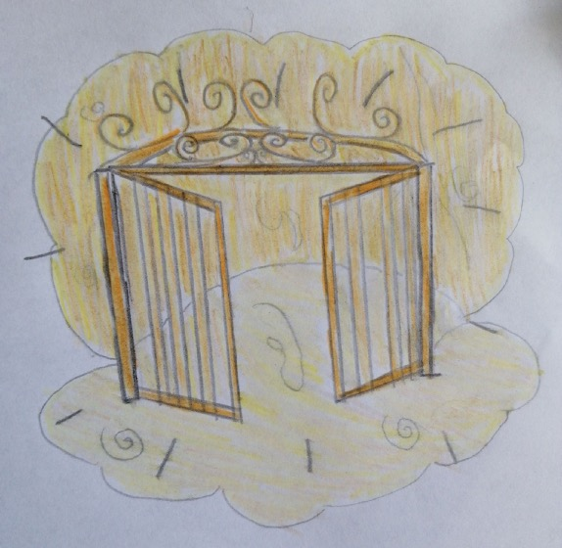
Xenia was home!
(Or was she???)
(Yes! She was!)

