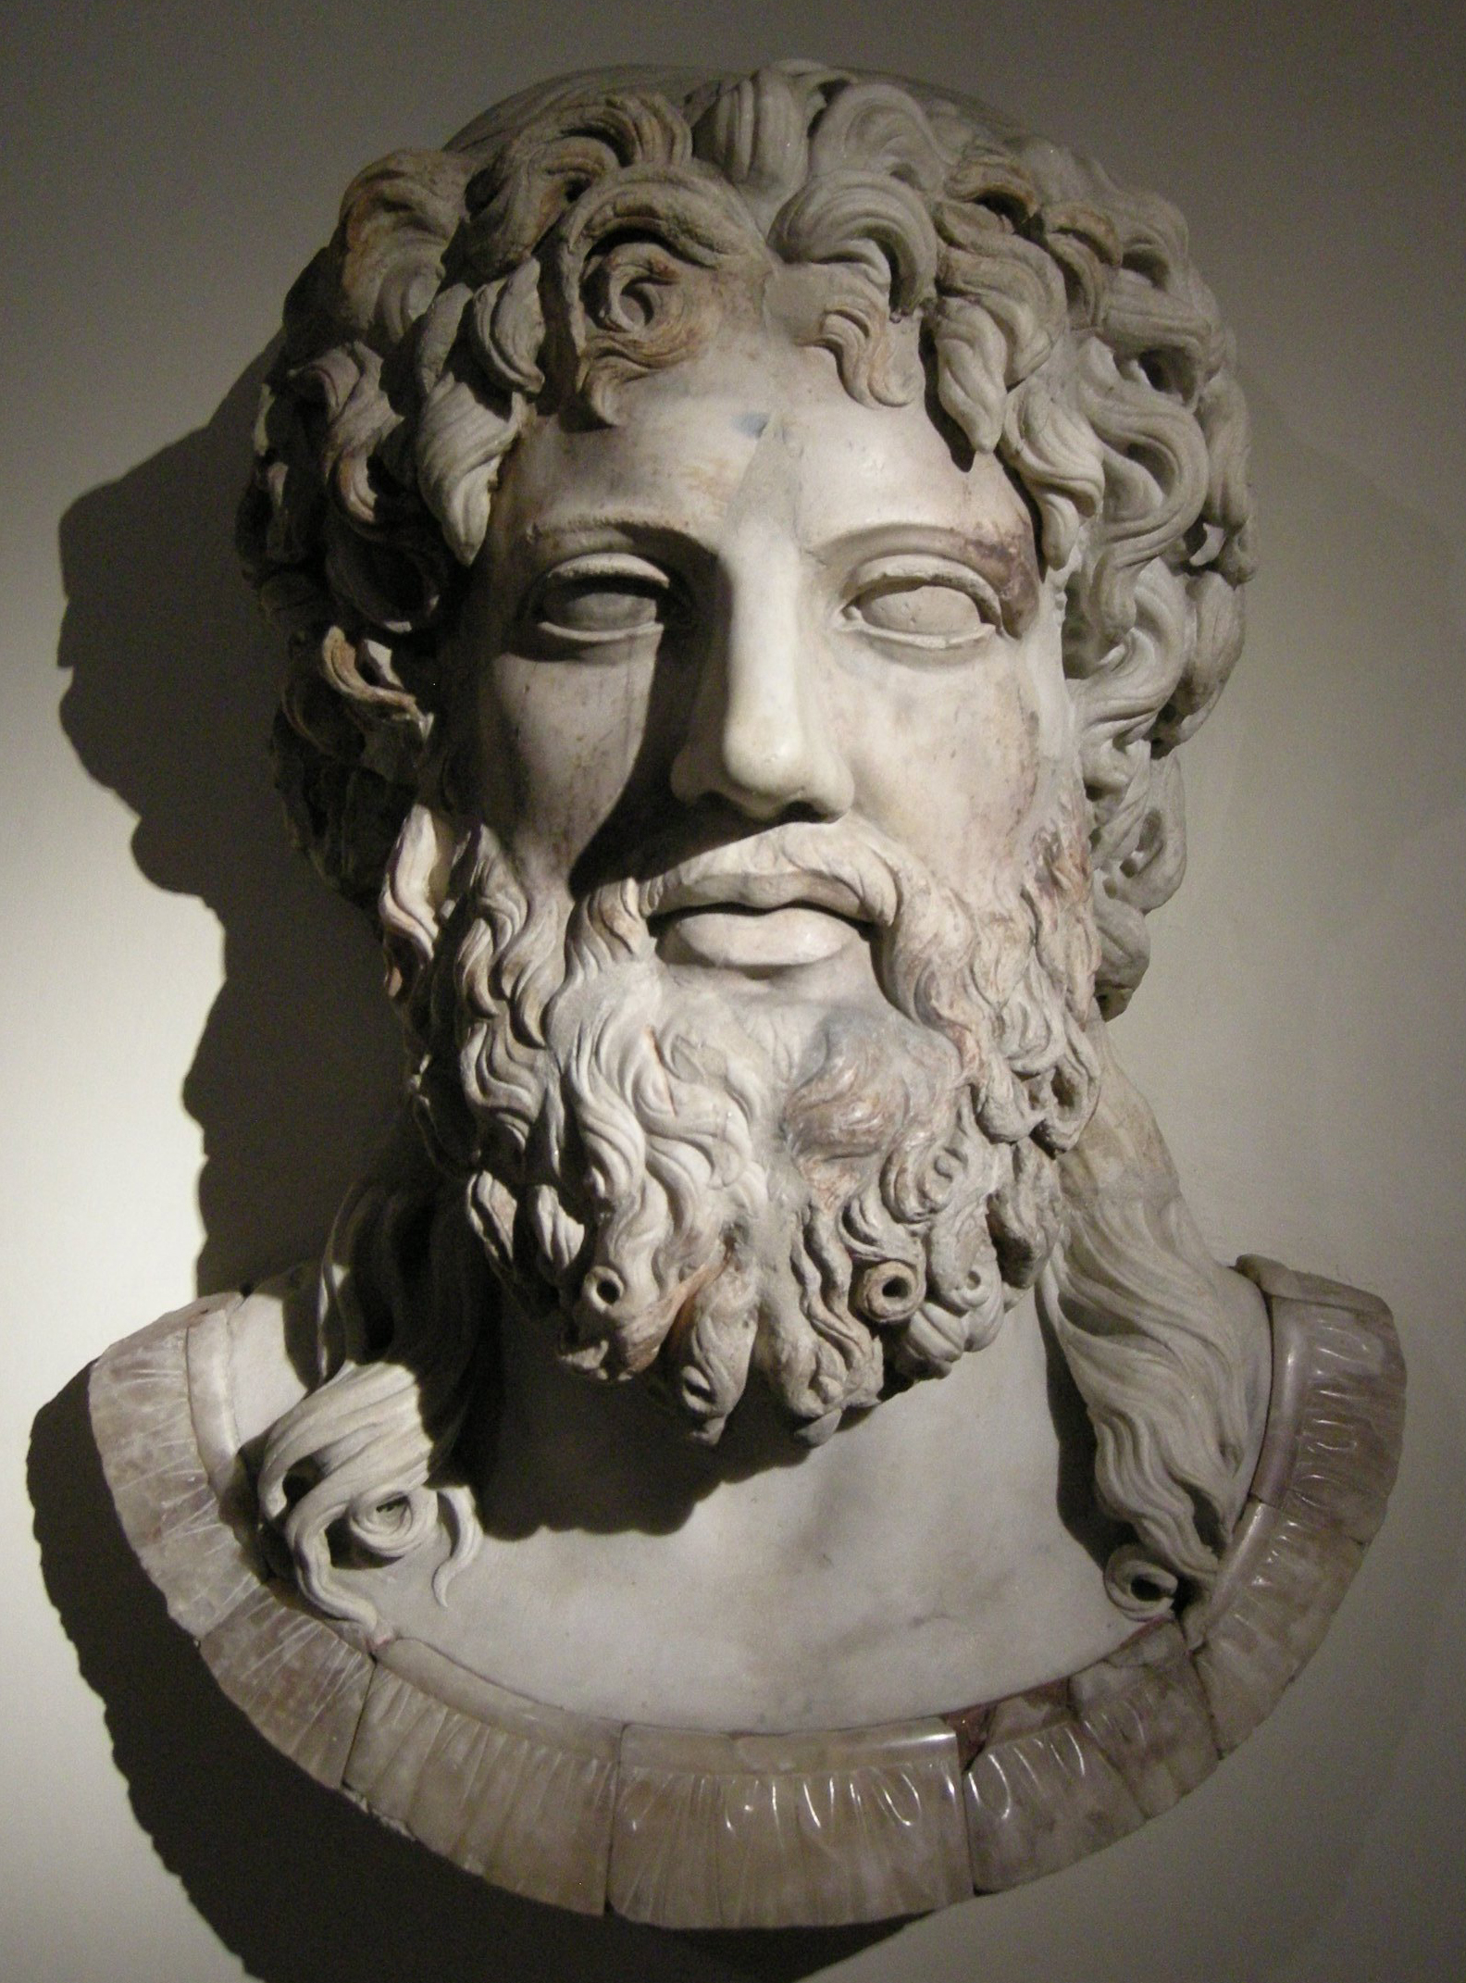
TOP TRUMP
Power: 98%
Strength: 97%
Importance: 100%
Weapons: 2 weapons
Worshiped: 75%
Zeus is the king of the gods. He launches thunder bolts at anyone who displeases him and can morph into an Eagle, Bull, Swan, A shower of gold and a Satyr. Some of Zeus’s children are Athena and Hermes.

ZEUS
This Photo by Unknown Author is licensed under CC BY-SA
This Photo by Unknown Author is licensed under CC BY-SA

