Monday 1st June
Look at each picture – what does it show? What is the link between each image?

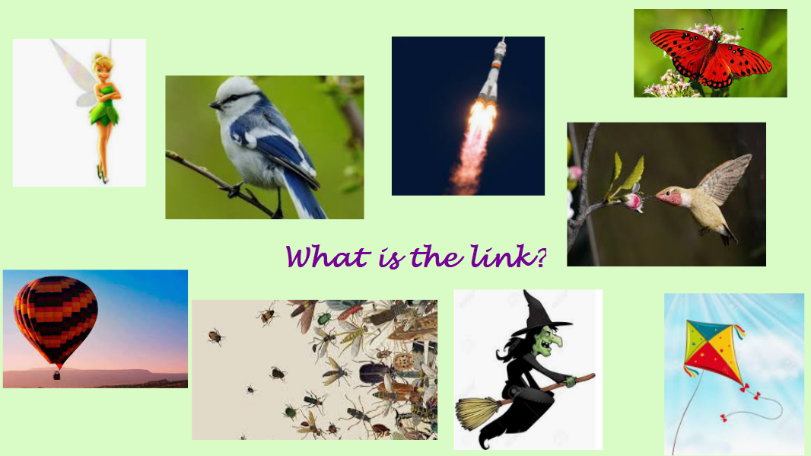

Look at the pictures – what do they show? Is the link still the same?
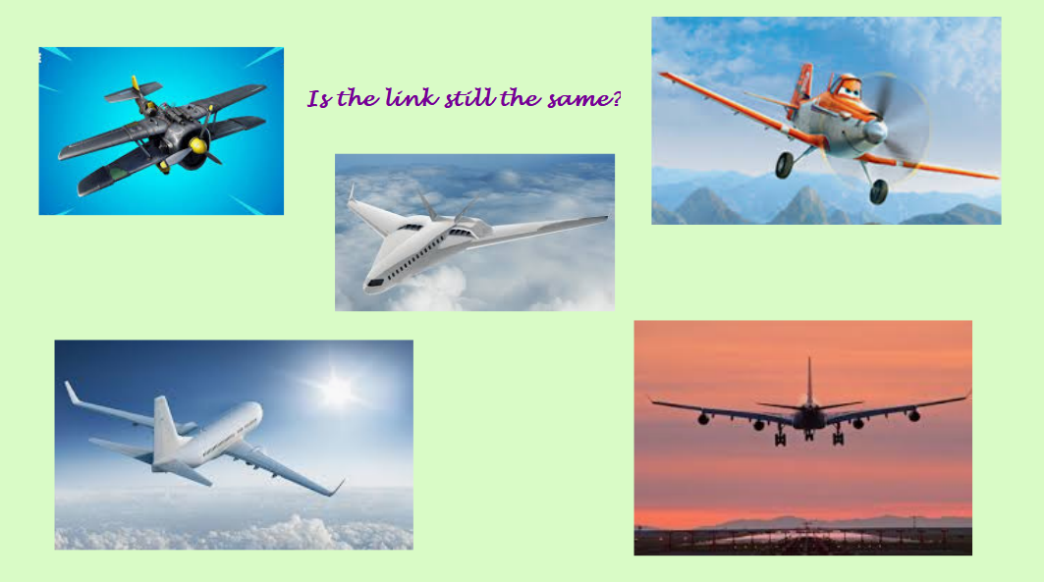

LO: To describe flight

Listen/watch each clip shown on the grid. For each one annotate/mind map the matching picture with words, think about what can be seen, heard, felt etc (example on following page)

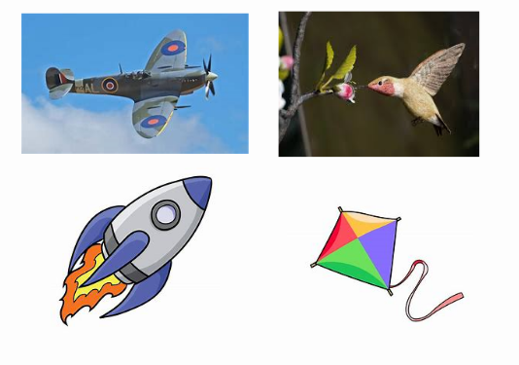
Five minute write
LISTEN to the clip and imagine something flying through the air (you can note down ideas while you listen if you want to).

Write for five minutes.

Example of mind maps for describing flight


