

Materials

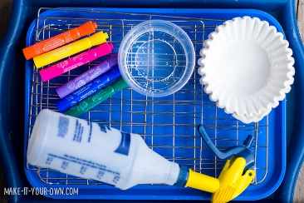
- Markers (non-permanent)
- Water
- Spray bottle (we find this industrial version easy for kids to use and long lasting!)
- Craft trays and/or plastic craft tablecloth
- Cooling racks
- Coffee filters
- Smock
People
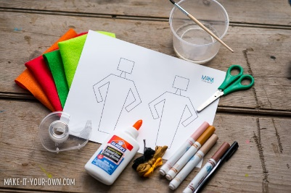
- Template
- Scissors
- Tape
- Multicultural markers
- Embroidery floss
- Paint brush & water *Optional
- Felt (or fabric, construction paper etc.)
- Craft glue

Directions -Coffee Filter Skirts
- Draw a simple designs on the coffee filter with markers. 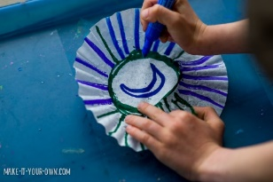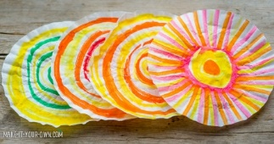
- Place your coloured filters into your trays and spray them with a fine mist of water. 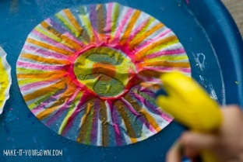
- Leave them to dry overnight.
- 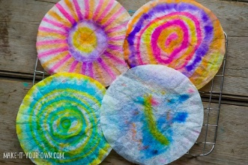
- Add any details to your filters. 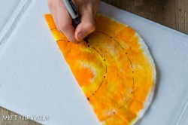
People
- Colour your people in. Then cut out. You could add a head dress at this point if you like.
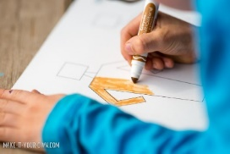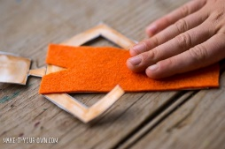
- Cut out a top for your person. We made it the length of the body and used felt, but you could make it as elaborate as you would like! Glue your clothing onto your person.
- Fold your coffee filters in half and then make any folds that you may like to form a skirt. You could make the coffee filter into trousers, by cutting a slit into it. 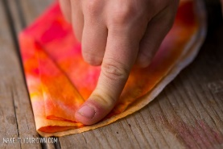
- Add your skirt to your person.
- 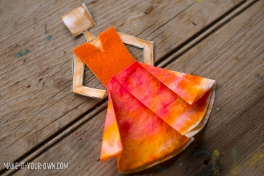
- We made a little felt belt to add a bit of polish to the edges, gluing it on the back
- Embroidery string or wool to make hair.
- 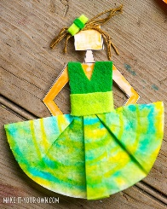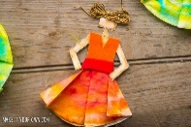
- You could add bead and feathers as well

