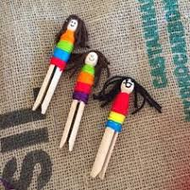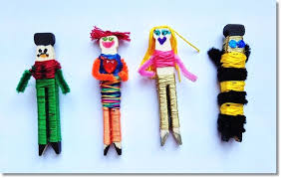

Worry Dolls are traditional little dolls originally made in Guatemala – the idea is simple – if at night you find yourself worrying about things (and worries have a habit of bothering you when you are trying to sleep), you tell your worries to these little dolls and place them under your pillow. The traditional worry dolls are very small, made from things like match sticks and scraps of fabric. Since then, there are lots of variations of making these bright and colourful worry dolls.
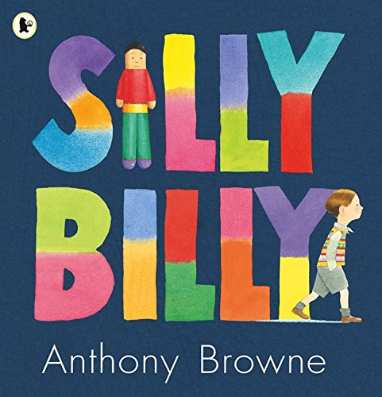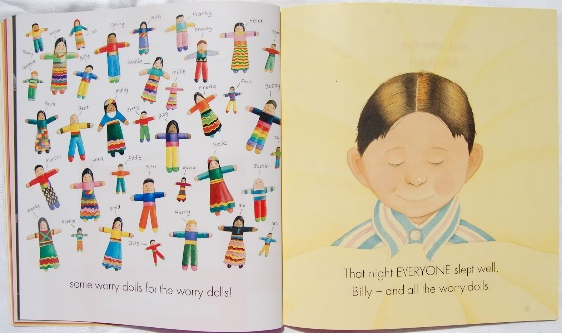

How to Make Worry Dolls with Pegs
April 1, 2020
Finally, I get to share these adorable Worry Dolls how to. I love the simplicity of these Worry Dolls as well as the bright and cheerful colours. I think Worry Doll Crafts are a great SUMMER CRAFT for kids – as you can make them and take them with you to Summer Camp or the Grandparent’s house. Wherever there is separation and a little worry.. these worry dolls will help!
First created in August 2017
Worry Dolls are traditional little dolls originally made in Guatemala – the idea is simple – if at night you find yourself worrying about things (and worries have a habit of bothering you when you are trying to sleep), you tell your worries to these little dolls and place them under your pillow. The traditional worry dolls are very small, made from things like match sticks and scraps of fabric. Since then, there are lots of variations of making these bright and colourful worry dolls.
DIY Worry Dolls – Materials –
- Old fashioned dolly pegs –Washed lolly sticks (craft sticks)
- Brightly coloured wool
- Pens
- A little glue (optional for hair)
- you can make these using sticks, just lolly sticks or even cardboard pieces stuck together. You can dress you worry dolls in wool like here, you can use fabric scraps to make them. Make them big or small, to suit your child’s needs!

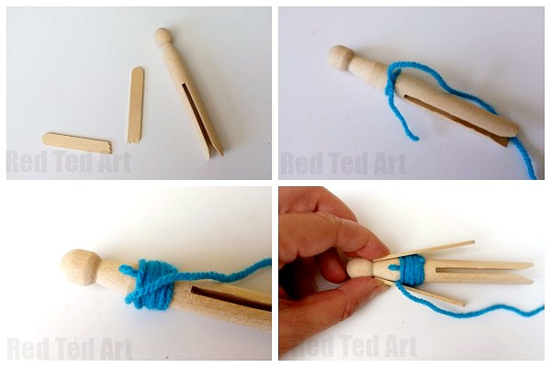
- Prepare your lolly stick by breaking it in half. Get it as “half as possible, so both arms are the same length.
- Tie your first colour around the waist of your doll and start wrapping your wool UP towards the head.
- Most peg dolls have a slant just under the head – aline your broken crafts stick pieces and hold in place. If you wish you can glue them in place first.
- 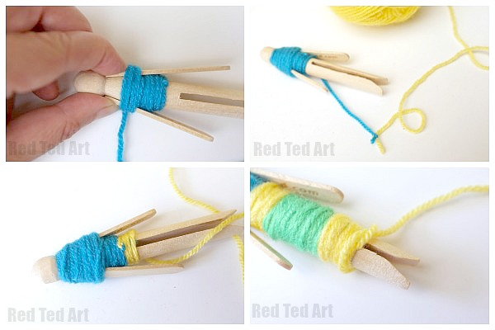
- Secure in place by wrapping your wool tightly around the craft sticks all the way up the neck. Then work the wool back down again – under the arms and back to the waist.
- Time for a colour change – simply cut your first colour and knot to the second colour. Then start wrapping! Hide your knot and knot ends by wrapping over them. Change colours as often as you like.
- When you get to the bottom of your doll, cut your wool and carefully make a little knot by looping it in itself. Then tuck any excess wool between the legs.
- 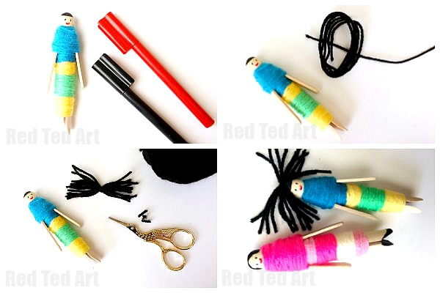
- Add a little face and hair using pens. As these dolls have their origins in Guatemala we like to give them black hair, but you can choose!
- (Optional), you can add some woolly hair by gluing strands in place!

