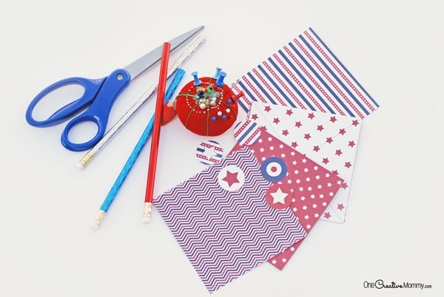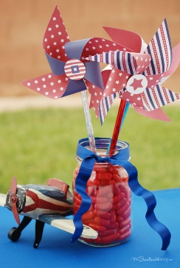

HOW TO MAKE A PINWHEEL:
RELATED: Fast and Frugal Patriotic Wreath, Tin Can Stilts Classic Toy Tutorial
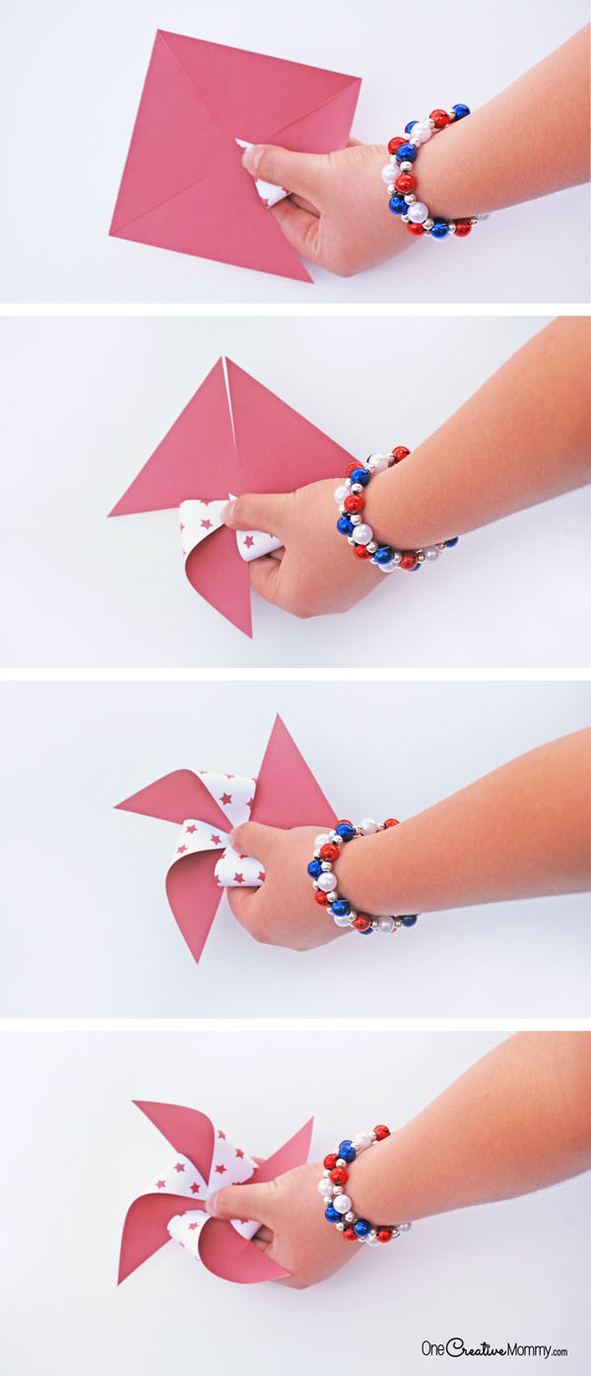
- Print your papers by clicking on the download button below. (You’ll get access to printables in large and small sizes.)

- Cut out the squares from the printable papers, and cut along the black interior lines to form almost-triangles. (Note that the lines do not go all the way to the center of the pinwheel. You are only cutting part way.)
- Bend every other corner into the center of the pinwheel (overlap the center x slightly).
- Release the corners. Using a thumbtack, poke a hole in the center of the pinwheel (through the x) and in every corner that you folded. I found it easiest to poke through the paper and into a pin cushion.

- Insert a pin into all four corner holes and then into the center hole. Push the pin into the side of a pencil eraser. (You can use the thumbtack instead of a pin. The thumbtack creates a larger hole than the pin, so if you use the pin, the wheel will spin more easily since it’s smaller than hole you created.)
- Choose a center circle from my patterns to glue over the pin, or use the pinwheel as is. Have fun!

