You are here: Home / Educational Crafts / Japan Crafts for Kids / Kimono Art Project for Kids

KIMONO ART PROJECT FOR KIDS
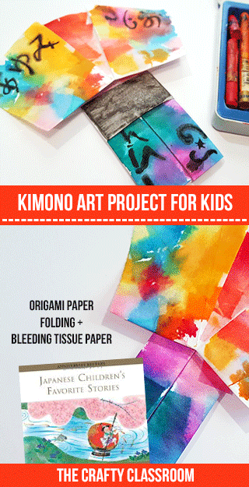
When learning about Japan, teaching children the art of paper folding is a must! Origami can be really easy to start learning and eventually children will be able to master some of the more intricate folding techniques. This kimono art project is great for children of all ages, but if you have younger children you might prefold the kimonos for them. Results are always stunning with this project
Materials:
- Origami Kimono
- Bleeding Tissue Paper
- Paintbrush & Water
- Watercolor Pencils (optional)

Art Project Tutorial:
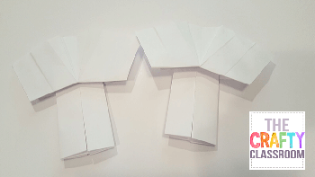

STEP 1

Fold your Kimono out of white paper. We used instructions for an origami kimono found here:
0:03 / 4:00

(ORIGAMI) how to make kimono (version 2) https://www.youtube.com/watch?v=VzIflZamv-U

View Resource
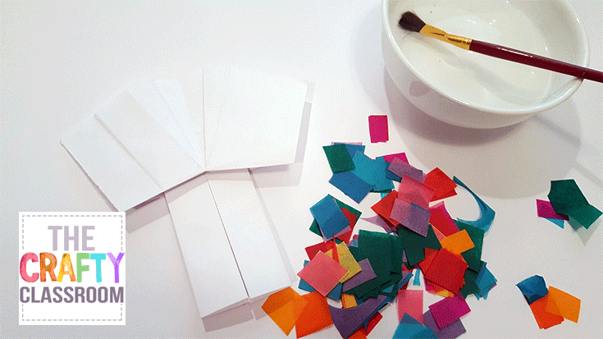

STEP 2

Cut small squares from bleeding tissue paper. Get a paintbrush and small dish of water
View Resource
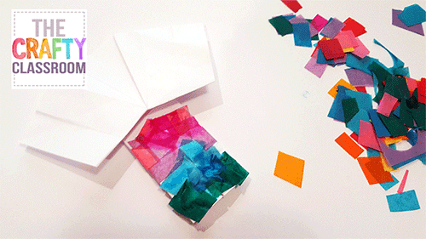

STEP 3

Wet your kimono and stick bits and pieces of the bleeding tissue paper on top of the water. Be thoughtful about what colors might bleed into other colorsl.
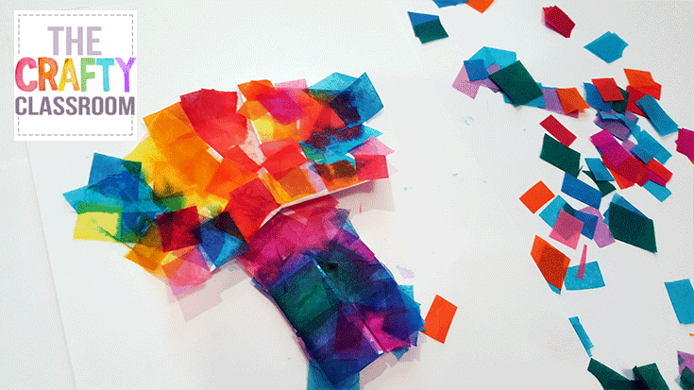

STEP 4

Fill up your entire kimono with tissue paper then set aside to dry.
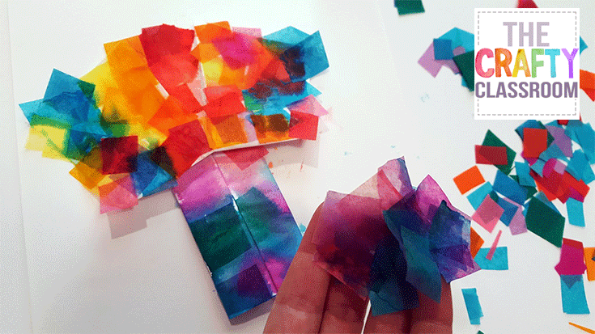

STEP 5

When dry, peel off the tissue paper to reveal the colors underneath.
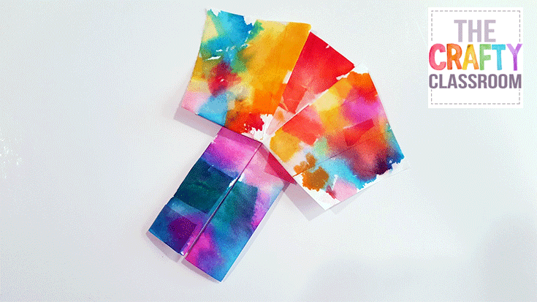

STEP 6

You can stop here if you like, the kimono is stunning!
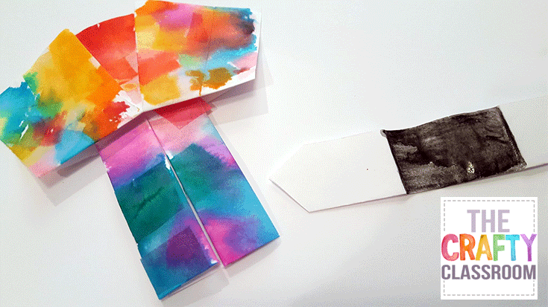

STEP 7

Or add in a paper belt, just cut a thin rectangle and paint black.
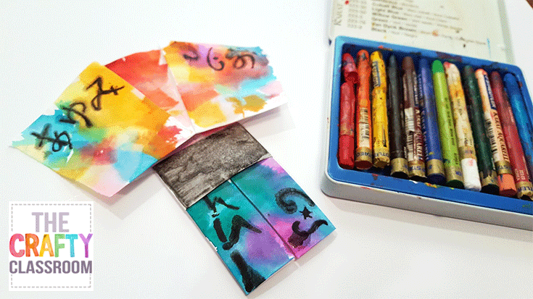

STEP 8

Research some Japanese art work or letters and add some details with watercolor crayons or pencils.
Share:

