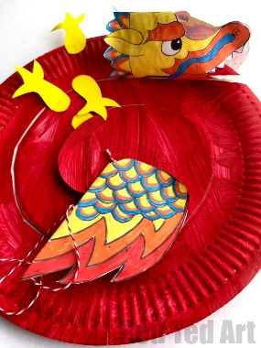
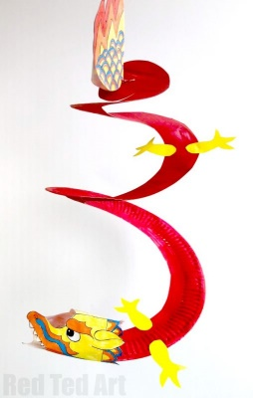
Chinese Paper Plate Dragon Twirler
Reference: https://www.redtedart.com/paper-plate-dragon-twirler/
Materials needed:
• Paper Plate
• Paint
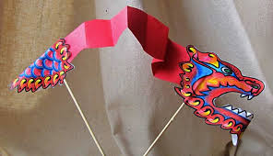
• Scissors
• Glue
• String
• Crayons/colouring in pencils
Instructions:
1. Paint a paper plate in red. Of course your dragon can be any colour – green, yellow, or maybe a mixture of colours
to represent the scales.
2. Let it dry and paint the reverse side.
3. Whilst waiting for the paper plate to dry, you can start colouring your Paper Plate Dragon Twirler template.
4. Cut out your details – do not cut the head or the tail in half. You need them to be joined. If you carefully fold your
head and tail in half, you can cut the two halves in one go – saving a little time.
5. Once your paper plate is dry, cut a spiral into your Paper Plate to make the Dragon Whirligig. It should look a bit like a
snail. (The thicker your snail twirls the more compact your Dragon will be. The thinner, the more elongated it will be.)
6. Take a piece of string and tie a knot one end. Then staple it into place.
7. Glue the dragon’s paper tail to the top of the dragon – make the string stick between the two dragon tail halves.
8. Assemble the head. You will need to glue the bottom of the dragon face together.
9. Add a little glue to the top of the nose and glue that too.
10. Glue the paper dragon’s head to the bottom of the whirligig. You can add tissue paper for fire if you wish.
11. Add the legs.


