CHINESE DRAGON CRAFT
PIN IT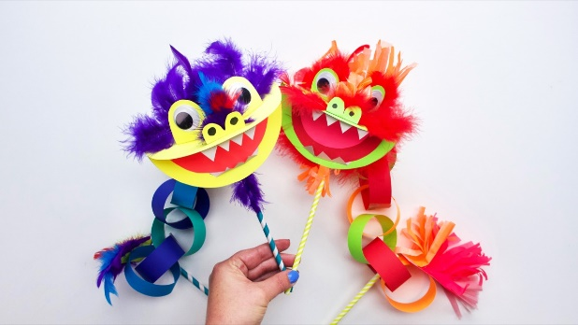
Dragons in Chinese culture are a symbol of wisdom and power, and thought to bring good luck to people. They are also used to celebrate the Chinese New Year with the dragon dance – the longer the dragon dances, the more luck will come in the new year!
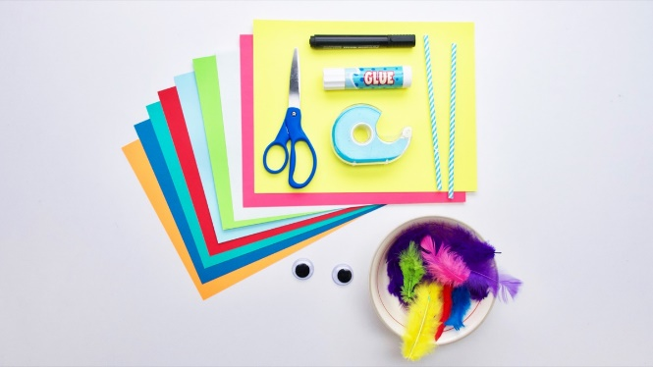

THINGS YOU’LL NEED
- coloured and white construction paper
- feathers or coloured tissue paper
- disposable chopsticks or two straws for the handles
- scissors
- large plastic eyes- you can draw these.
- bowl for tracing a circle for the head
- smaller bowl for tracing a circle for the inside of the mouth
- glue stick
- tape
- black marker
To make the head, trace a circle onto a piece of coloured paper, use any colour you like! Cut out the circle and fold it in half. Trace a smaller circle on red paper but it could be any colour paper for the inside of the mouth. Cut it out and fold it in half, then glue onto the inside of the large circle.
For the eyes, draw an arched shape big enough to surround each of the plastic eyes. Make sure to leave an add extra length at the bottom that will be used to fold and glue to the head. Draw an ‘m’ shape for the nose with added length at the bottom, again to fold and glue.
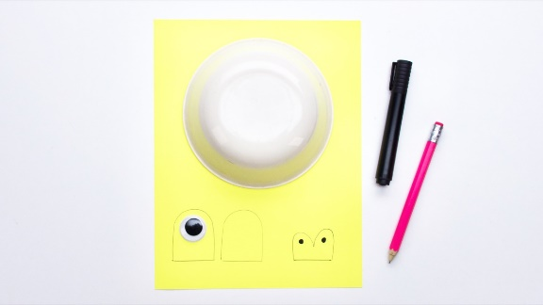
Draw the top and bottom teeth on white paper, again with added extra length at the bottom. Cut out the shapes and glue eyes, nose and teeth into place. Cut out a triangle shape for the tail and set aside for later
. 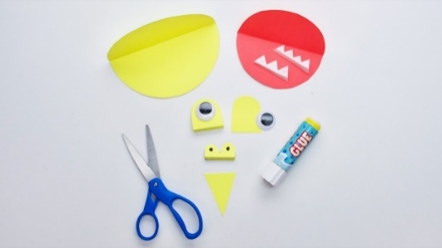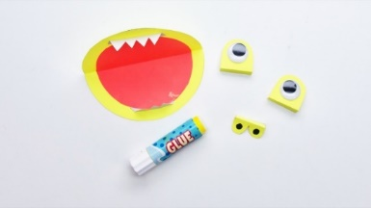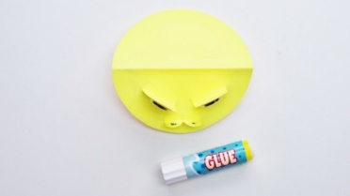
To decorate the head of your dragon, use a glue stick and glue the feathers behind the nose and eyes. If you don’t have feathers, you can use tissue paper instead!
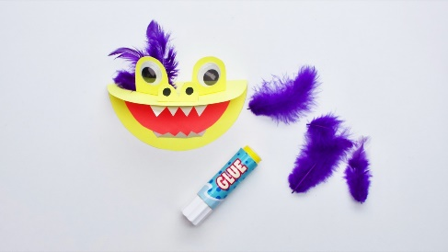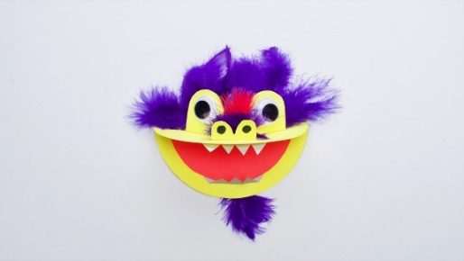
To make the body of your dragon, cut strips from coloured paper about one inch in width, and the length of your paper.
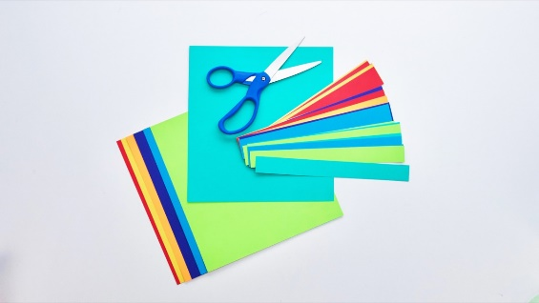
Link the strip ends together with glue and tape for extra strength. You can also use a stapler for this part.
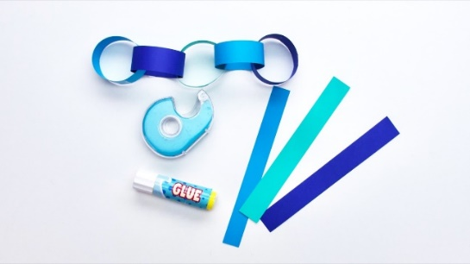
Once your links are together, glue and tape into the back of your dragon head. Glue the triangle onto the top of the last link to make a tail and decorate it with feathers!
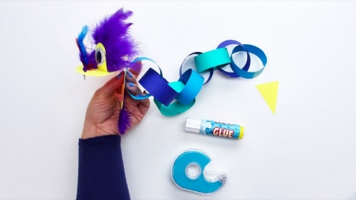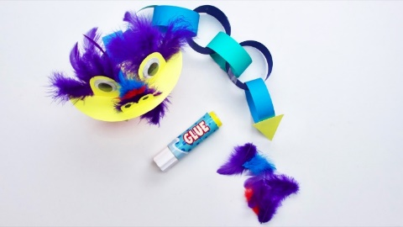
To make your dragon into a puppet, you can tape two straws or chopsticks onto the dragon. Tape one at the back of the head and the other onto the inner side of the last link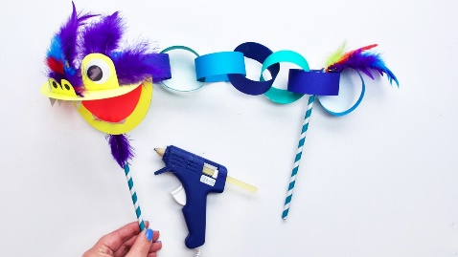
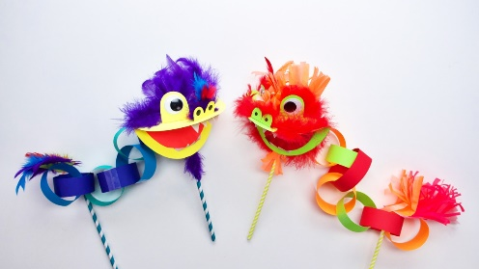
Now your Chinese dragon is ready to dance!

