IY Lunar New Year Fans
In ancient China, fans came in various shapes and forms, and were made in different materials such as silk, jade, bamboo and even feathers. The original Chinese fan, the circular tuánshàn 团扇, is said to have been modeled after the full moon, and signifies union and happiness. For over 3,000 years they have been used as a fashion statement, a way to keep cool or provide shade, and a way to display art. Fans are also viewed as good luck charms and expressions of generosity.
Check out how we make paper fans using plain white paper (copy paper offers the best weight). You can either have the kids decorate their paper first or use solid colors. Better yet, do you have pages and pages of your child’s art and drawings stacked up in the kitchen? This is a great craft to turn that art into an object!
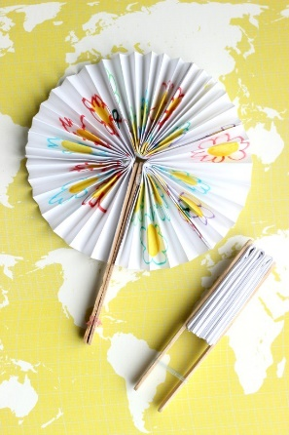
Supplies:
(3) 5×8″ pieces of copy paper
2 craft sticks
1 tiny hair band
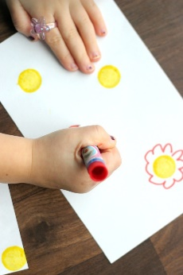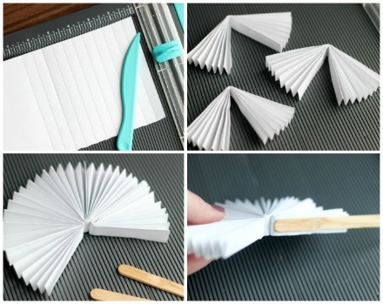
Step 1: Score each paper on the 1/2″ mark. You can fold it without scoring, but scoring will help children get even folds all the way across.
Step 2: Accordion fold each piece of paper. Then fold each paper in half.
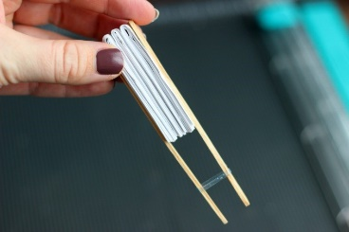
Step 3: Using a glue stick or hot glue, adhere each fan piece together until you have one seam left then glue a craft stick to each side. Close with a mini hair band and it is ready to travel with you!
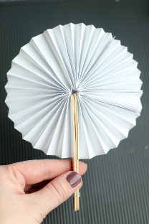
Step 4: Once dry, open up your fan and enjoy! Tip: use the mini hair band to hold the craft sticks together when your fan is open.

