KOI WATERCOLOR ART PROJECT FOR KIDS
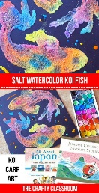Koi fish are beautiful carp that hold special symoblism in Japanes culture. Koi ponds are placed in beatiful, tranquil settings and japanese gardens. Encourage children to learn more facts about Koi before you create this stunning project.
Materials:
- PosterBoard
- Watercolors
- Salt
- Glue
- Eye Dropper
- Pencil/Paintbrush
- Reference Photo

Art Project Tutorial:
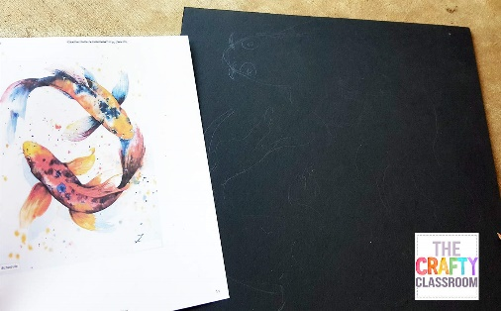

STEP 1

Choose an inspiration photo for your project. Using a pencil lightly sketch a drawing on your poster board.
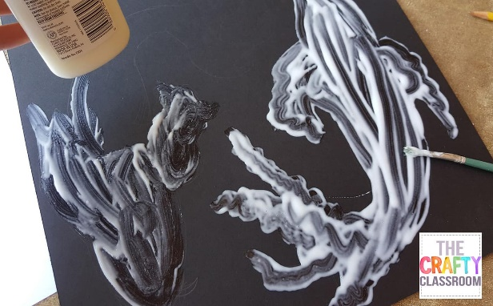

STEP 2

Using glue and a paintbrush fill in the shapes you just drew.
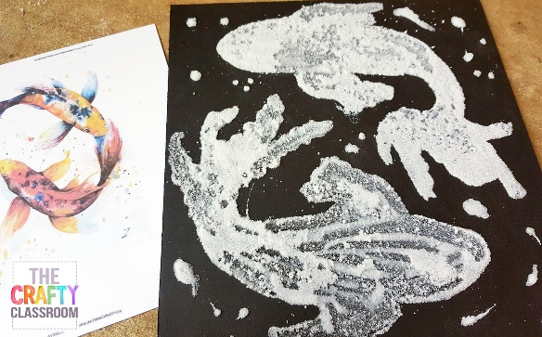

STEP 3

Cover the glue with table salt. Let dry for a minute then turn your board over so the extra salt falls off. If you wait to long to do this the glue will flatten out under the weight of the salt and your shape will be distorted a bit.
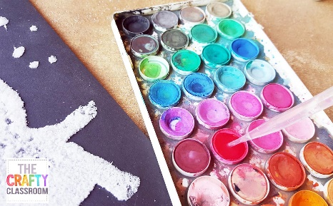

STEP 4

Using a water dropper, fill your water color paints with water. Mix well then used the dropper to slurp up some colors.
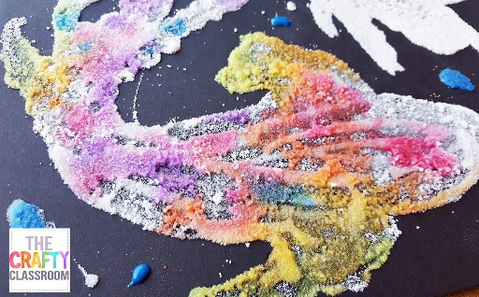

STEP 5

Drop the watercolor over the salt and watch it spread out and blend.
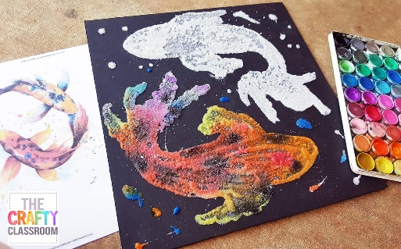

STEP 6

Use your photo reference as a guide, but don't feel you need to stick with it exactly
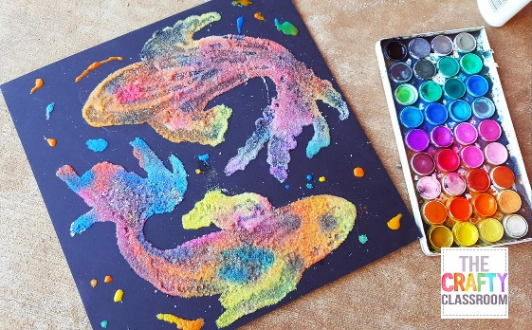

STEP 7

Finish dropping colors on your board until you're happy with how your project looks! Let dry and give this project to a friend!

