Easy Bicycle Craft for Kids with just 4 items
AFFILIATE LINKS PR SAMPLE
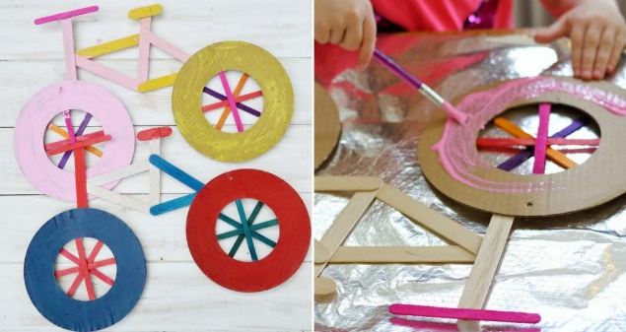
Tour de France will be made up of 21 stages and will cover a total distance of 3,351 kilometres. These colourful bicycles are made from using only card, lolly sticks, paint and glue. They look effective enough to hang on the wall
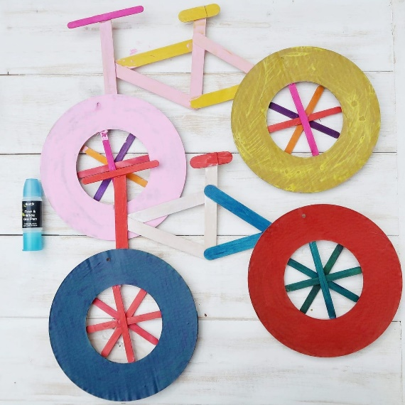

Lolly Stick Bicycle Craft – You will need
- Cardboard hoops (craft shop wreath templates work well) or paper plates
- Lolly sticks. We used two sizes – the usual smaller ones and some large lolly sticks
- Paint
- Glue
- Any other decorations or embellishments you would like to use
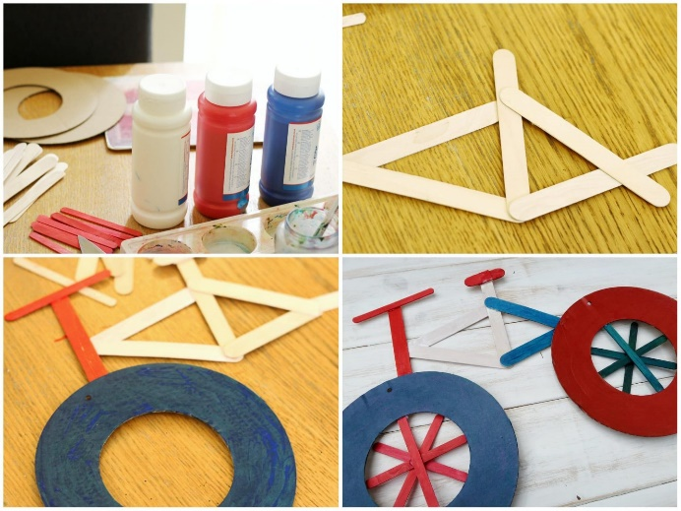

Lolly Stick Bicycle Craft – Method
The first thing you need to do for this bicycle craft is make the frame, seat and handlebars of the bike. Arrange them in the shape shown above and glue them in place. If you are using general craft glues you will need to leave them to set for a little while. I also used lolly sticks for the spokes and so I glued those into a spoke shape, using four lolly sticks. I then glued those to the inside of the wheel. If you are using paper plates, you will need to cute a circle in each one first, in order to create the wheel shape.
You could also use string for spokes. Simply make holes around the wheel and thread in through holes, weaving a spoke pattern. Tie off and stick down with tape at the back when complete.
You can either paint the wheels and frame separately and then glue together, or create the whole bicycle shape and then let the kids go wild, decorating their bicycle craft however they would like.
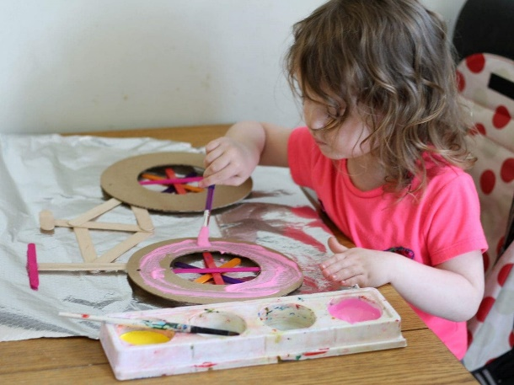

An Easy Craft for All
Above, you can see Littlest decorating her bike. She chose multicoloured lolly sticks for spokes and painted the rest of the bike pink and yellow. I also decorated a bicycle with her and I opted for Tour de France themed colours of blue, white and red. You could also make smaller versions of this bicycle craft, using smaller lolly sticks and cut up toilet rolls. This would make a great craft for the front of a greetings card.
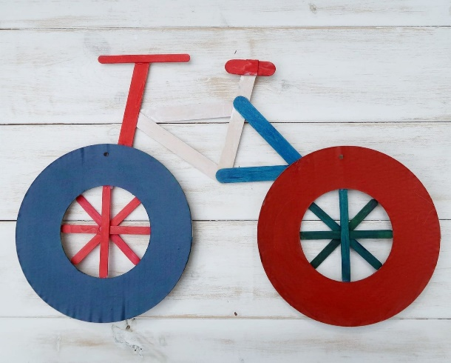
I think you could also use the bike as a kind of notice board. It would be easy to pin smaller items to the wheels and spokes. And there you have our Bicycle Craft in celebration of the Tour de France. Make sure you tune in next month to see the cyclists in action.

