HOW TO MAKE A TOILET ROLL KNITTING LOOM
For your conviencience, this post contains affiliate links. As an Amazon associate, I earn from qualifying purchases.

SUPPLIES:
- Cardboard Roll (toilet roll, paper towel roll, food wrap roll etc.)
- 2 Craft Sticks (cut in half to make 4 pieces)
- Hot Glue Gun
- Coloured Duct Tape (optional)
- Small Buttons (optional)
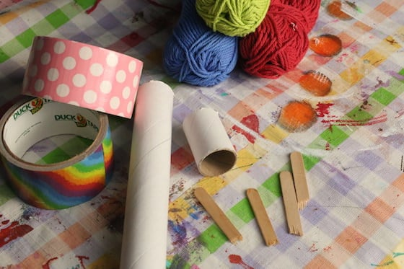

TO MAKE YOUR LOOM:
Cut or break 2 craft sticks in half, and position the 4 pieces evenly around your cardboard roll. With a hot glue gun, glue them in place with about 3/4 inch extending beyond the end of the cardboard roll.
Cover the roll with colourful duct tape and hot-glue a button to the top of each craft stick.

HOW TO KNIT WITH YOUR CARDBOARD LOOM

YOU’LL NEED:
- yarn
- wooden skewer (optional)
- child friendly sewing needle
- scissors

CASTING ON YOUR STITCHES
Drop the end of your yarn down the centre of the cardboard roll, letting a 4-5 inch tail hang out the bottom.
Keep a gentle hold on this tail of yarn as you begin to cast on your stitches.
Working from the ball of yarn, wrap the yarn around one craft stick, once, in a clockwise direction, and then take your yarn to the 2nd craft stick, winding it once in a clock wise direction. Move on to the 3rd and 4th craft sticks in the same manner wrapping the yarn around them once in a clockwise direction. (see video above if you need clarification)
Nudge the yarn down to the bottom of the stick and start knitting!
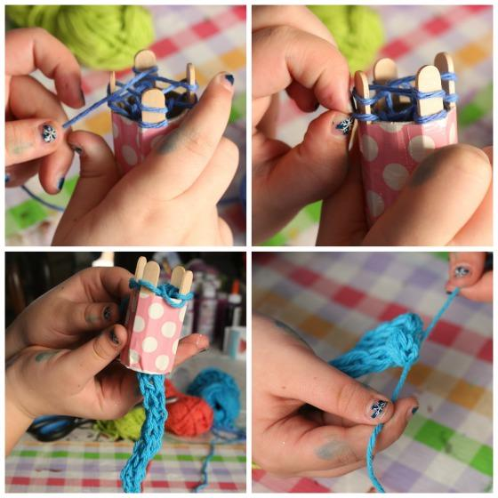

KNITTING YOUR STITCHES
Lay your yarn across the first craft stick, just above the stitch that you cast on.
With your fingers or a wooden skewer, hook the lower stitch and gently pull it out over the stitch above it, and all the way off the craft stick. let it fall to the other side of the craft stick. Gently pull the tail of the yarn to tighten the stitch a little.
Continue around your loom, doing the same with each craft stick: lay the yarn across, pull the bottom stitch up and over the yarn above it and off the end of the stick.
Remember to give the tail of yarn a tug from time to time to tighten up the stitches.
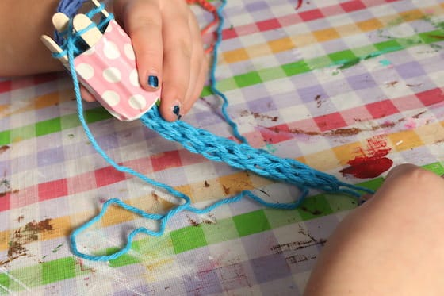
Continue with this form of french knitting until your project reaches a length that you’re happy with.

CASTING OFF
When you reach the end of your project, you’ll need to cast off your stitches in a way that secures them, and keeps your project from unraveling.
Cut your yarn, leaving a tail at least 6 inches long.
Thread a sewing needle with this tail.
Each of your craft sticks should have just one stitch remaining on it, and these stitches will form little loops once removed from the sticks. Slide the sewing needle up under one of the stitches and slip the loop off the craft stick.
Proceed around the loom, until all of the stitches (loops) are off the loom, and on the yarn on your sewing needle.
Gently pull on the tail and the loops closed, and tie a knot close to the loops to secure everything in place.
Tie a similar knot at the opposite end of your knitting.

TO PREVENT STITCHES FROM SLIPPING OFF YOUR KNITTING LOOM
When kids are knitting with a loom made from toilet rolls and craft sticks, it can be a little frustrating because the yarn can easily slip off the craft stick when they’re making their stitches.
To solve this problem, I glued a small button to the top of each craft stick. The buttons act as stoppers, and prevent the yarn from sliding off the stick when you pull your stitch over the top.


