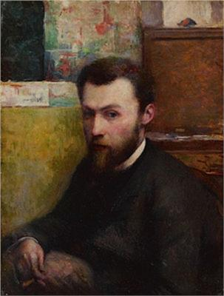
Georges-Pierre Seurat was a French post-Impressionist artist. He is best known for devising the painting techniques known as chromoluminarism as well as pointillism.
Born: 2 December 1859, Paris, France
Died: 29 March 1891, Paris, France
On view: The Museum of Modern Art, MORE
Nationality: French

To understand this, Let’s take a look at one of Seurat’s most iconic paintings, ‘ A Sunday Afternoon on the Island of La Grande Jatte‘.
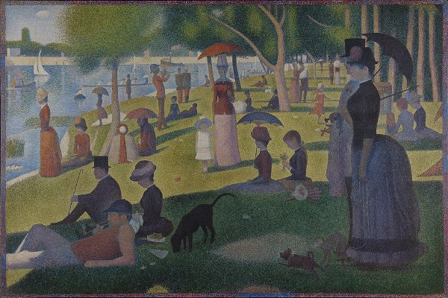

What do you notice about the painting above? You can see that the colours have a softer feel, and though the overall work looks clean and neatly outlined, there is a lot of depth in terms of colour and shade. This is because of Seurat’s favourite painting technique – pointillism.
In pointillism, tiny dots of colour are put together on canvas, repeatedly, till it fills in an entire area. So rather than the painter mixing up these dots of paint, your brain mixes it up so your eyes see it as a single picture rather than a combination of dots. You could say that the painting has an almost ‘digital’ feel to it!
Take a look at a detail from the painting above:
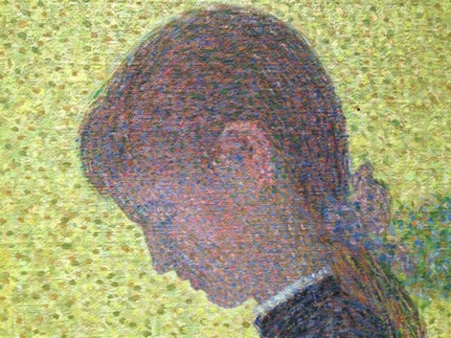
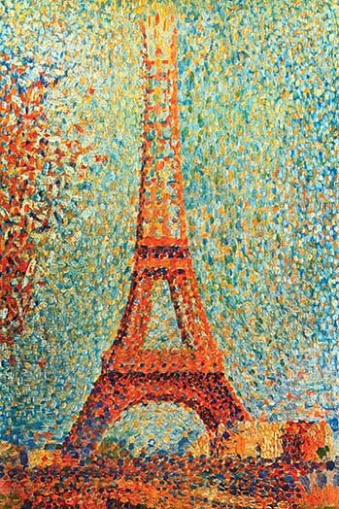
All this sounds quite scientific, and that’s because it is! Seurat went through scientists’ writings on colour theory, and how the human eye views colours. After lots of study, he realized that one could use colours by understanding them scientifically, and this led to the creation of a new language called Chromoluminarism. Science!

The Eiffel Tower by Seurat
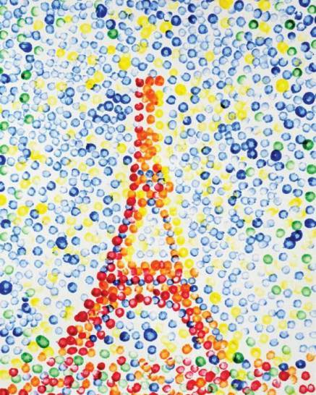
Childrens Challenge

- Draw the outline of the Eiffel tower.
- Use a cotton bud to fill in the tower in the style of Seurat.
- Think about where you are using the colour and layering the paints to create new colours without pre mixing.

Younger children could use template, if at home you could always use other matereials to fill in the Eiffel tower.

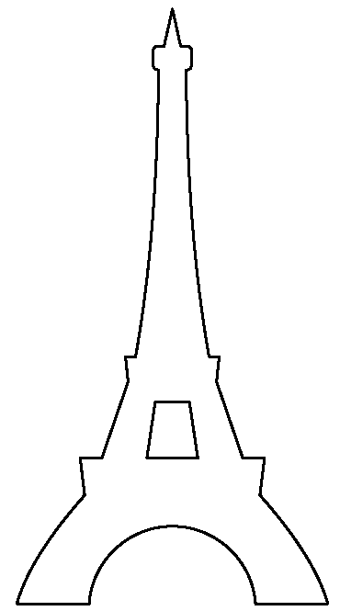

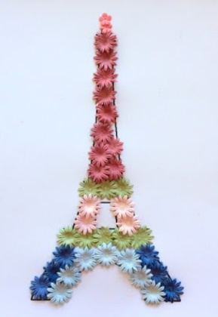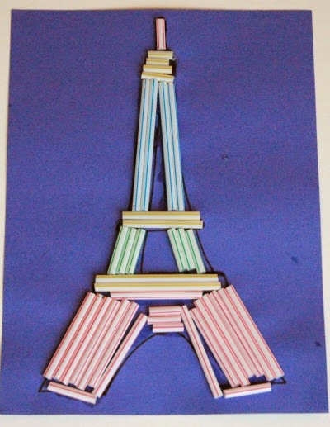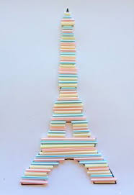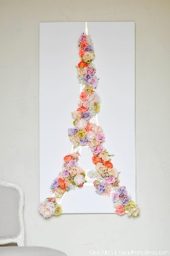

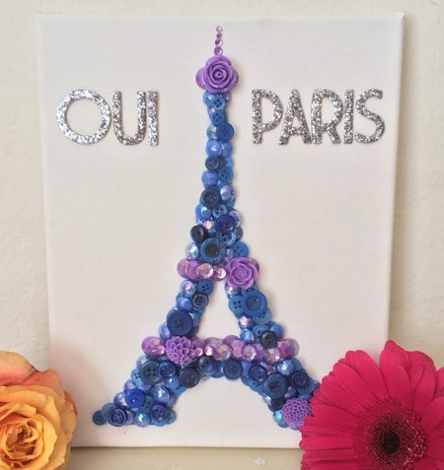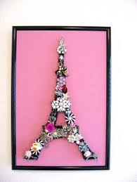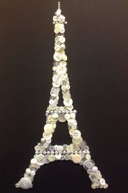

Children Challenge

- Draw the outline of the Eiffel tower.
- Use a cotton bud to fill in the tower in the style of Seurat.
- Think about where you are using the colour and layering the paints to create new colours without pre mixing.

