Science - Africa
Activity 1
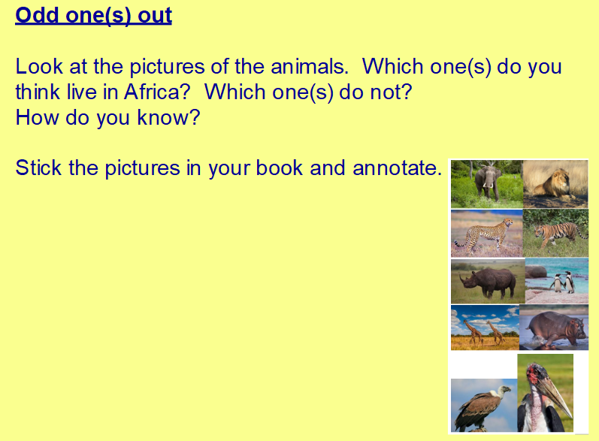
You can print the pictures from
https://merdon-junior-school.secure-primarysite.net/summer-2-week-4/

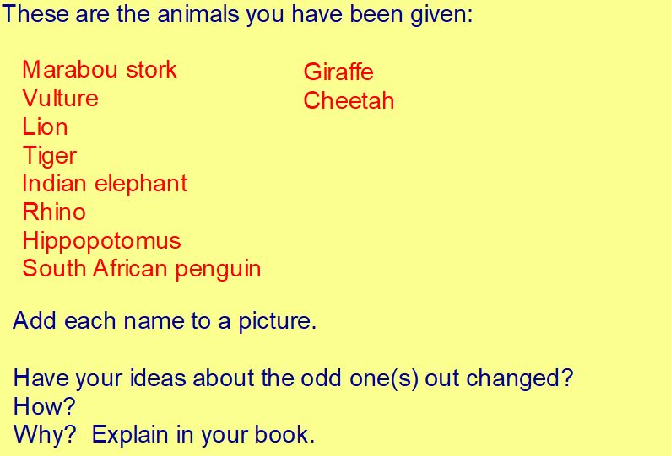

We are going to be looking at the different habitats in Africa.
What type of habitat is used in this film clip? (follow the link below). How many different animals can you name?
http://www.viewpure.com/GibiNy4d4gc?start=0&end=0

The Savanna
Activity 2
Use the information in the resources to find out about the savannah.
https://merdon-junior-school.secure-primarysite.net/summer-2-week-4/
(power point and notes to read)

Now test your knowledge of food chains using the following link
https://www.bbc.co.uk/bitesize/topics/zbnnb9q/articles/z93vdxs

Activity 3
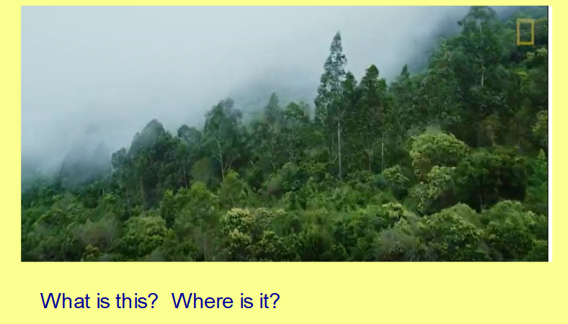
https://kids.nationalgeographic.com/explore/nature/habitats/rain-forest/#/1463363139525
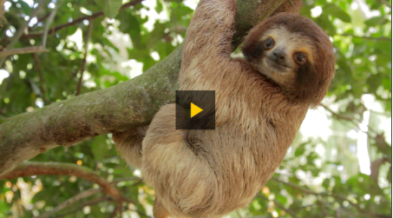
Read the information on the website about rainforests and watch the video

Read the ‘Life in the rainforest’ information sheet in resources https://merdon-junior-school.secure-primarysite.net/summer-2-week-4/

Activity 4

What other habitat is found in Africa?
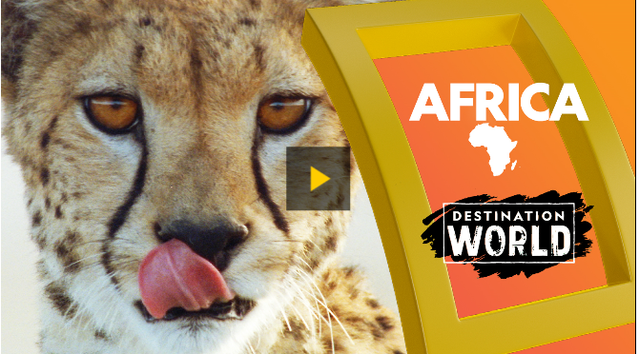
Watch this video at:
https://kids.nationalgeographic.com/explore/nature/habitats/rain-forest/#/1249693251856

Activity 5

Using the world biome map below show the different habitats found in Africa – remember to use a key.
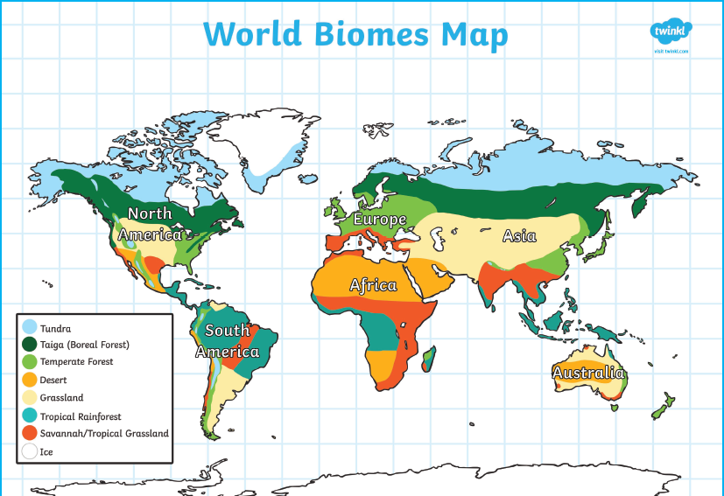

There is a blank map of Africa on the next page.



