LO: To identify and locate a range of habitats

Who lives where?
Match the habitat to the correct animal

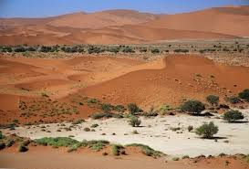
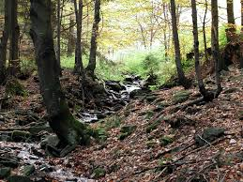

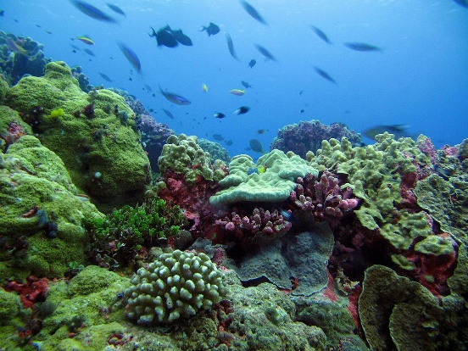

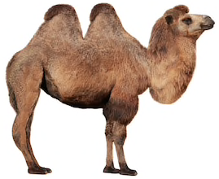
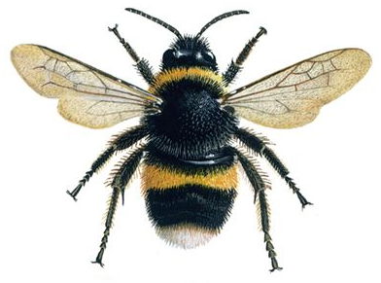
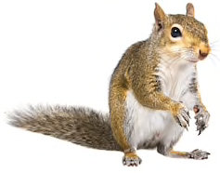

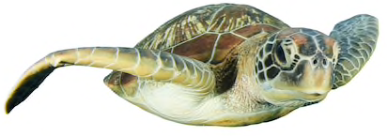

What do you think a habitat might be?
_________________________________________________________________________________________________________________________________________________________________________________________________________________________________
Watch the video clip and complete the sheet below! What must a good habitat have? Tick the important boxes
https://www.youtube.com/watch?v=ZrSWYE37MJs
Lots of shelter
Looks nice
Food and water
Safe and protected
Bright and sunny

There are habitats everywhere, even around you right now…
Mr Perkins found a snail in his football boots!
What habitats you can find? This might be in your house, garden or somewhere else. What animals live in this habitat?
Draw your favourite habitat you have found!

Challenge - What’s the strangest habitat you can find?

