LO: To identify and classify a living thing according to its characteristics

Watch the video and complete the task underneath the clip
https://www.bbc.co.uk/bitesize/topics/zn22pv4/articles/z3nbcwx

What makes an insect, an insect? What are the features?
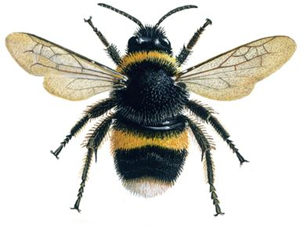
Label the similar features of the beetle that classify it as an insect
HEAD
THORAX
ABDOMEN
SIX LEGS

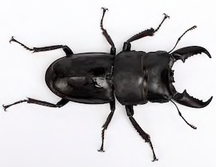

Can you find any differences between these two insects?

__________________________________________________________________________________________________________________________________________________________________________________________________________________________________________________________________________________________________________________________________________

Now we understand how we classify an insect; we now need to make a suitable habitat for them. You are going to plan and create your very own bug hotel!
Planning
Draw a design for your bug hotel. This hotel can be in your garden, or a suitable area close by.
You need to think about…
- What features does your hotel need to make it an appropriate habitat for an insect
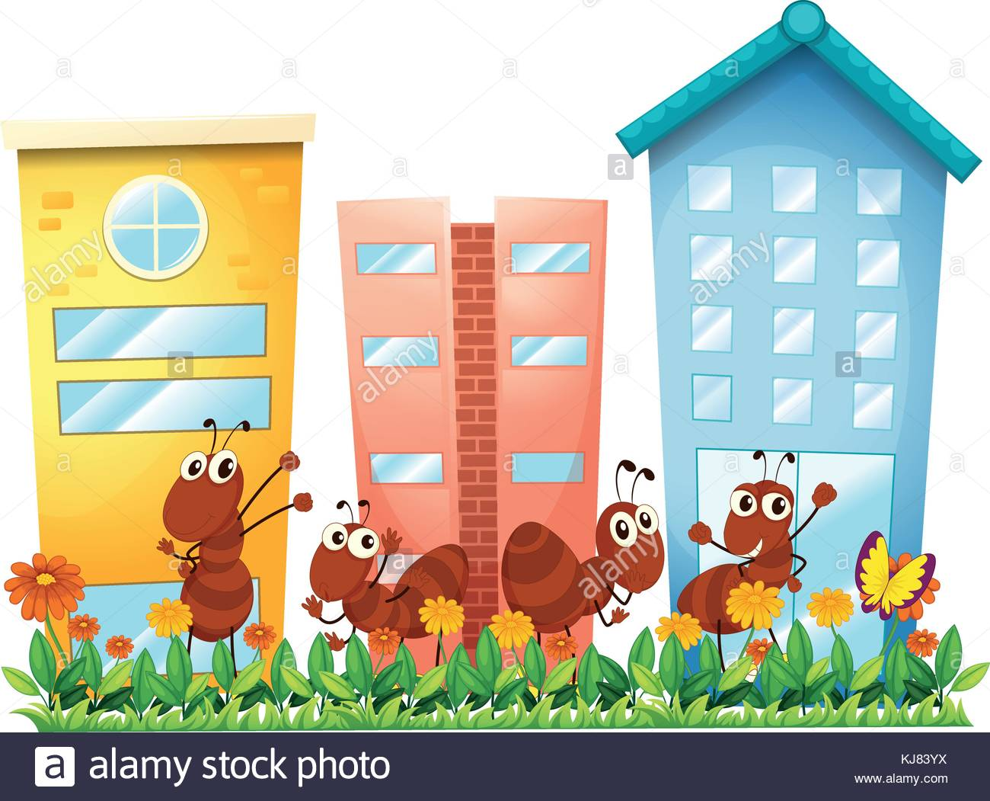
- Explain why you have included each feature of your hotel

Design
Using your plan to create your very own bug hotel!
Challenge – Come up with a creative name for your bug hotel!

