Dear Chandlers Ford residents

We have been offered a fantastic deal from a local adventure playground company for some new equipment for the playground. Using the money Merdon Junior School have raised, and because of the heavy discount we have been offered, we are able to buy similar equipment to that shown below.
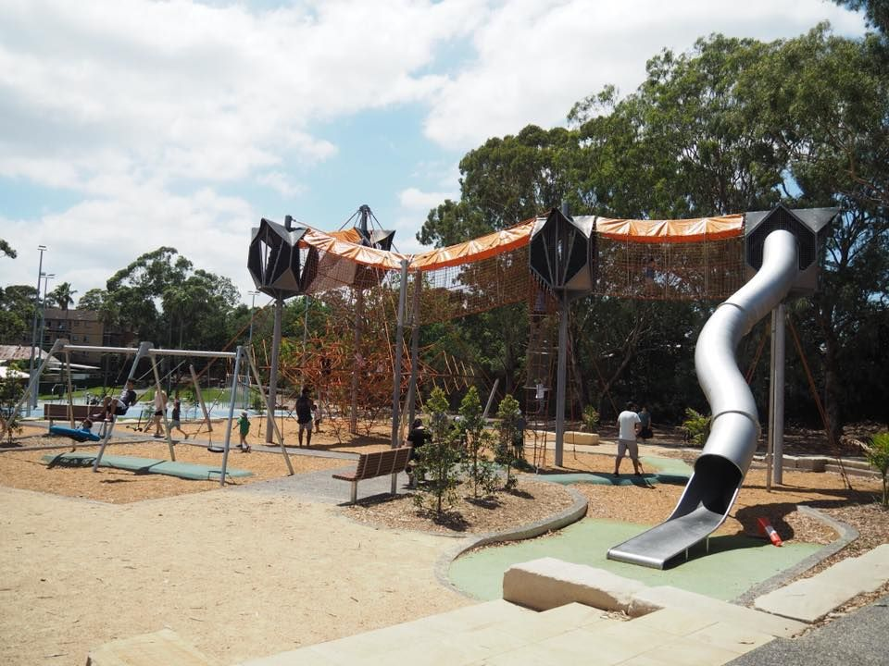

However, because of the size of the adventure playground, the only place that will be big enough to house it will be the wildlife and pond area. We would have to drain the area and put safety tarmac down before being able to build upon it. We are asking for your feedback to this idea. How often is the wildlife/pond area used at the moment? Do you think the new play equipment will be a good idea?

Kind regards

Mr P Erkins
Mayor of Chandlers Ford
LO: To understand and explain how changes in an environment can affect wildlife and their habitats.

You need to think of both positive and negative reasons why the Mayor should build his playground, and positive and negatives reasons why he should keep the wildlife area.

Here are some ideas to consider…
- Might the playground get children active?
- What habitats will be affected?
- Will Chandlers Ford get even more visitors?
- Could the playground create new habitats?

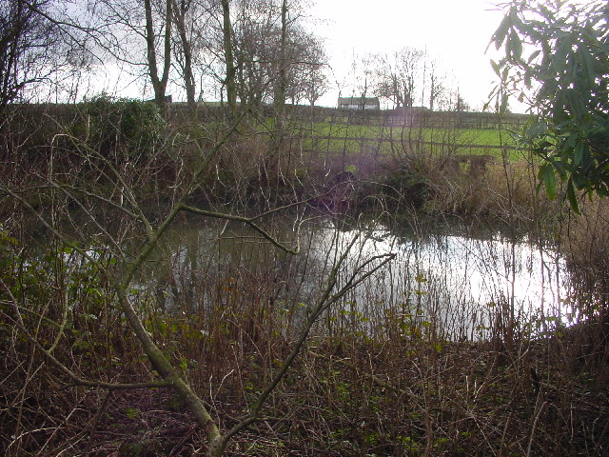

Challenge: Can you draw an environmentally friendly playground that could be placed alongside the wildlife and pond area to best preserve the habitats?

Positive
Negative

Adventure Playground

Positive
Negative

Wildlife Area

