Flint and Fire

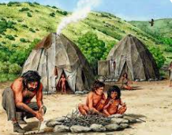

What will I be learning?

Which knowledge will I learn?
- What was life like in the Stone Age?
- What can we learn about life in the Stone Age from studying Skara Brae?
- How did life change in the Bronze Age?
- What was life like in the Iron Age?

What skills will I use?
- Use evidence to build an image of the past
- Use a range of resources to find information
- Identify key things that changed between periods

What questions do you have?
Vocabulary
chronology
hunter-gatherers
Skara Brae
Stonehenge
Bronze Age
Iron Age
Neolithic
Danebury
archaeologist

