What is the Earth made of?

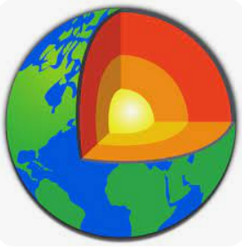

What will I be learning?

Which knowledge will I learn?
- What did we learn about materials in Year 1 and 2?
- What is inside the Earth?
- What do we see when we look closely at rocks?
- How are rocks formed and classified?
- Which rocks are the most porous?
- Which rocks are the hardest?
- How are fossils formed?

What skills will I use?
- Making systematic and careful observations
- Record findings using scientific langage, drawings and labelled diagrams.
Vocabulary
rock
grains
sediment
igneous
sedimentary
metamorphic
porosity
porous
soil
humus
fossil
core
- Use results to draw simple conclusions
- Set up simple enquiries
- Report on findings from simple enquiries
What questions do you have?

