Dear parents,

In June of year 4 all children sit a statutory timed multiplication check online. As part of the preparation for this, and because times tables are a key building block in the children’s mathematical fluency, we are writing to stress the importance of your children practicing their times tables at home.
The children all have access to Times Table Rockstars, which using the gig function can tell you which times tables the children are most confident recorded on their ‘heat map’. This is accessible through the following steps.


Click ‘My stats’ and then ‘Fluency’

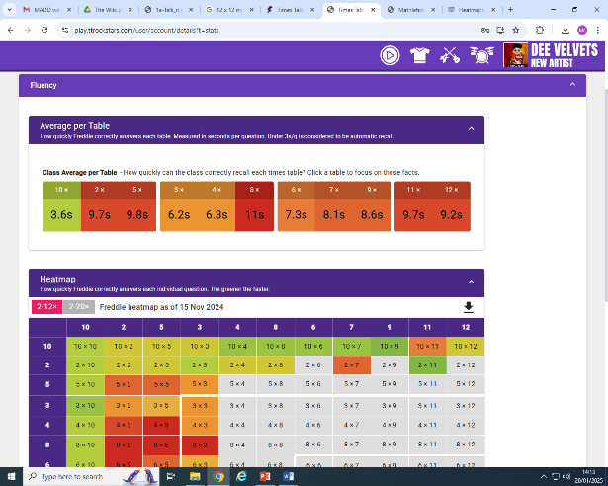

View your heatmap which colour codes which strengths and next steps you have.

Our stats show that many of the children aren’t accessing TT Rockstars to practice regularly, and we have been working with the children on which times table facts to focus on practicing most.
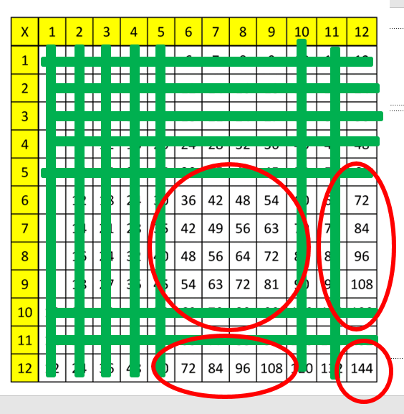
Most of the children feel very confident working on their 1x 2x 5x 10x and 11x. Many feel quite confident with their 3x and 4x tables. When you remove those from the times table grid you are left with only the following facts to focus on:
You can also remove any reversals from these 25 facts, e.g. 7 x 9 = 9 x 7 leaving only 15 facts to learn:

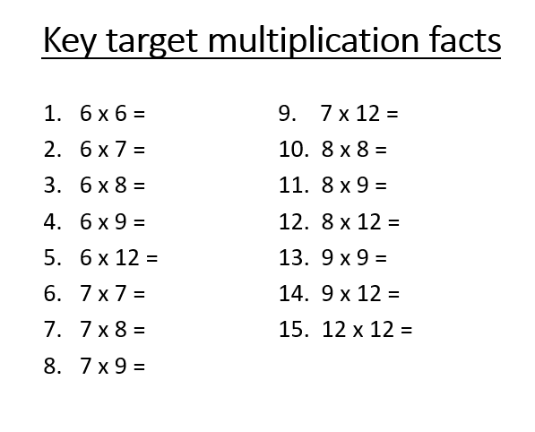

This presents a much less intimidating task! We will be practicing these in class regularly. We are also aware that some children find retaining their times table facts more challenging, and we adapt accordingly in school. However, as we always say to the children, there is no great trick to learning your times tables, it just takes lots of practice and overlearning!


Here is a link to a useful website which mimics the ‘real’ MTC test, which can be accessed at home.

We hope this helps in assisting your child to practise their times tables effectively, and if you have any queries regarding ways to practice, or the multiplication check, please contact either Mr Leigh or Miss Johnson-Hall.

