
Set: Wed 17th Jan Due in: Tuesday 23rd Jan
Maths Homework

Maths homework is set to support your child’s learning. The tasks will vary from week to week.
This half term we will be working on the 3 and 4 times tables for our Rock Stars Maths. Please keep learning the multiplication and division facts at home. Don’t forget to practise 2x 5x and 10x too.
Recall and use facts from the 4x table. Next week we will be looking at both multiplication and division facts for the 4x table. Have a go at these activities to practise your fluency and speed. We will be using this to help us in class next week.
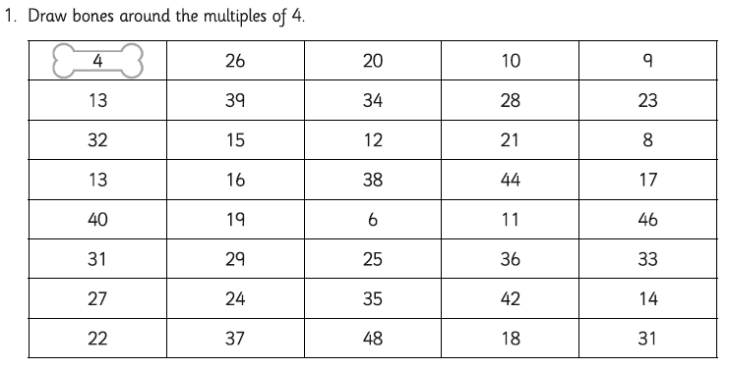

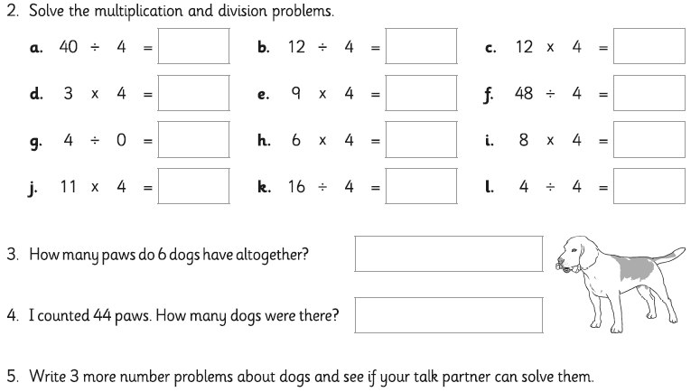

Parent Comments

Challenge
How can your 4x table help you to solve these:
160 ÷ 40
70 x 4
80 x 40
360 ÷ 40

