
Set: Wed 24th Jan Due in: Tuesday 29th Jan
Maths Homework

Maths homework is set to support your child’s learning. The tasks will vary from week to week.
This half term we will be working on the 3 and 4 times tables for our Rock Stars Maths. Please keep learning the multiplication and division facts at home. Don’t forget to practise 2x 5x and 10x too.
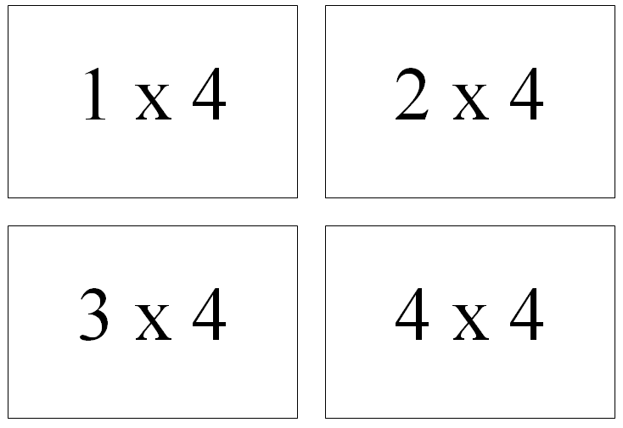
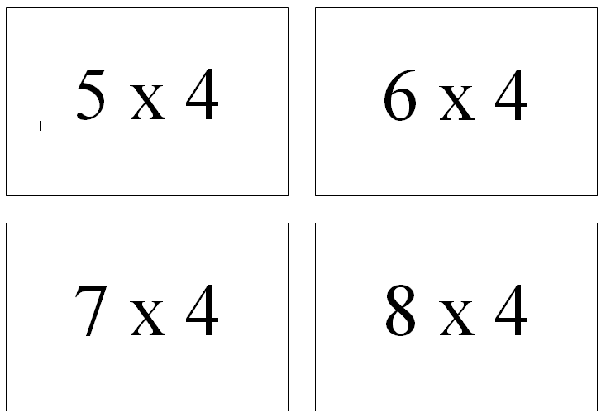
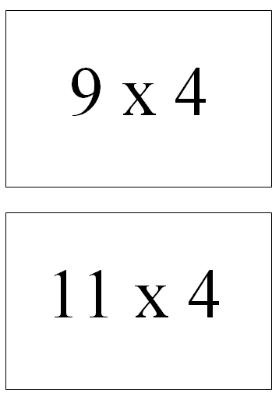
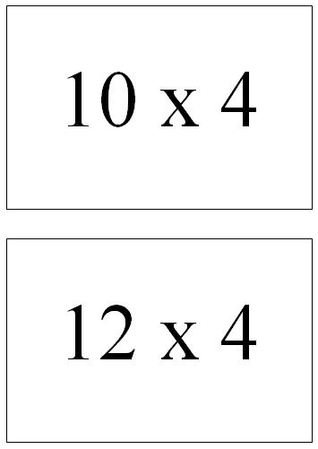
Recall and use facts from the 4x table. We are continuing to look at our 4x tables and specifically practising our speed and fluency when answering questions. Cut out these flash cards and write the answers on the back. You can either look at the number sentence to answer the questions or look at the answer and figure out the number sentence.
Parent Comments

