
Set: Wed 31st Due in: Monday 5th Feb
Maths Homework

Maths homework is set to support your child’s learning. The tasks will vary from week to week.
This week we have been looking at the relationship between multiplication and division.
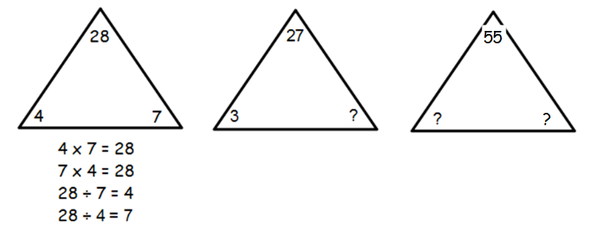
Write the four number sentences for the triangles below, one has been done for you:

Now create your own triangles and write the number sentences below:
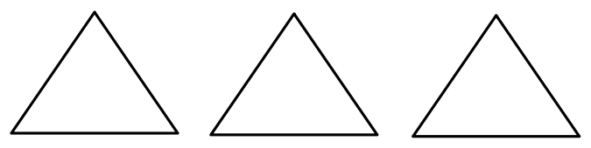

Challenge: If you know that 4 x 6 = 24. What other facts do you know?
Parent Comments

