
Set 22.11.17 Due in 27.11.17
Homework Week 4

Thank you for the applicants to be a Mars explorer you certainly considered the skills you would need.
Below are the lyrics to the song Year 5 we will be singing this Year at our annual Carol Concert. Please could you learn them?

Below is a link to the song, watch the video. It features Soviet cosmonaut Yuri Gagarin. Can you research Yuri Gagarin and create a fact sheet about him? Look at the Year 5/6 spelling list in your Home School Book can you include any of the words in your fact sheet-how creative can you be?

A Spaceman Came Traveling
Chris de Burgh
A spaceman came travelling on his ship from afar,
'Twas light years of time since his mission did start,
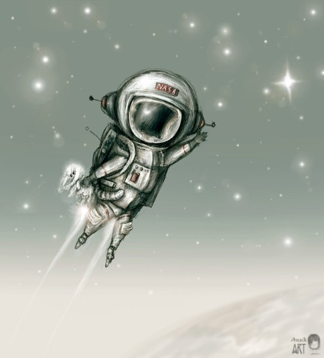
And over a village he halted his craft,
And it hung in the sky like a star, just like a star
He followed a light and came down to a shed,
Where a mother and child were lying there on a bed,
A bright light of silver shone round his head,
And he had the face of an angel, and they were afraid
Then the stranger spoke, he said "Do not fear,
I come from a planet a long way from here,
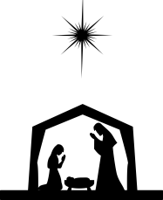
And I bring a message for mankind to hear, "
And suddenly the sweetest music filled the air
And it went La La
Peace and goodwill to all men, and love for the child
This lovely music went trembling through the ground,
And many were wakened on hearing that sound,
And travellers on the road, the village they found,
By the light of that ship in the sky, which shone all round
And just before dawn at the paling of the sky,
The stranger returned and said "Now I must fly,
When two thousand years of your time has gone by,
This song will begin once again, to a baby's cry"
And it went La La This song will begin once again
To a baby's cry
And it goes La La Peace and goodwill to all men, and
Love for the child
Oh the whole world is waiting, waiting to hear the song again,
There are thousands standing on the edge of the world,
And a star is moving somewhere, the time is nearly here,
This song will begin once again, to a baby's cry

Songwriters: Chris De Burgh
A Spaceman Came Traveling lyrics © BMG Rights Management US, LLC
https://www.youtube.com/watch?v=Ma8P4bDtJH8

