More Practise - Easier - Making the Whole
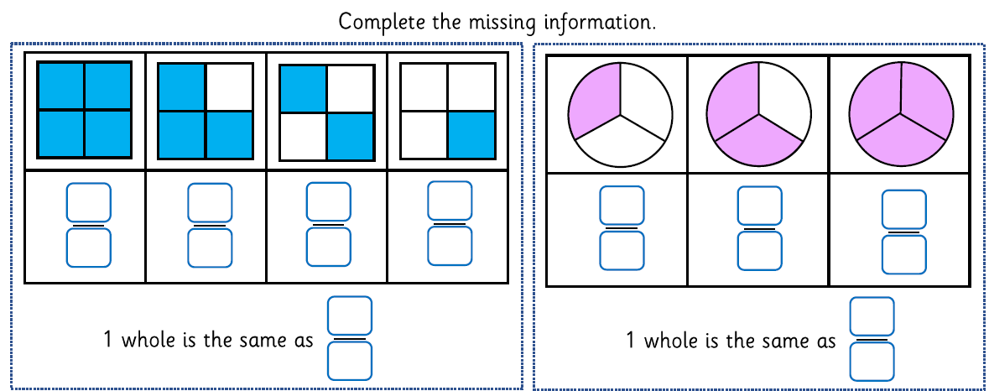
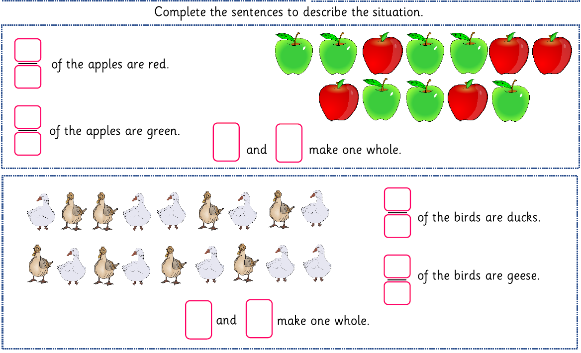

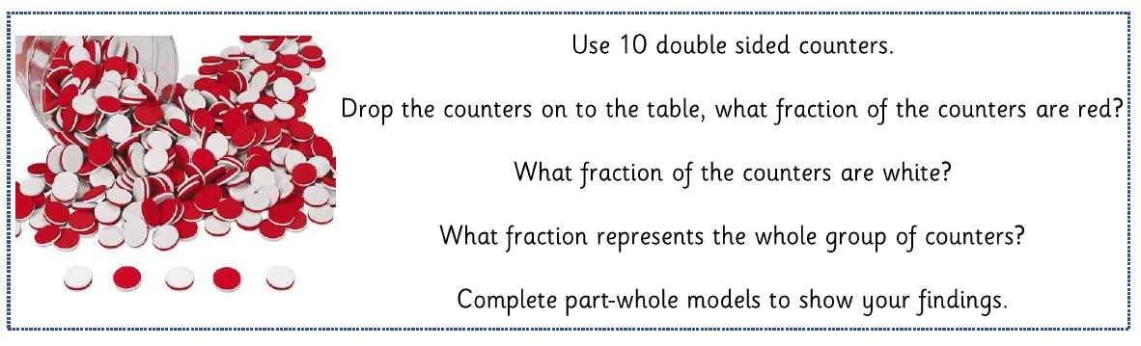
More Practise – Trickier - Making the Whole
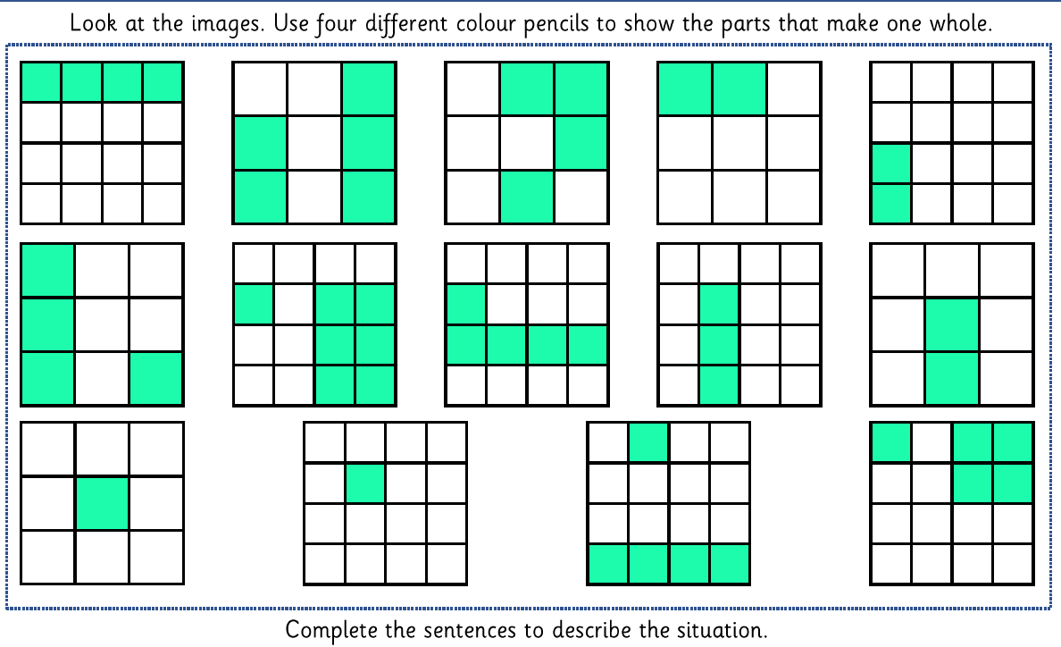
eg $\frac{4}{16} and\frac{12}{16}=\frac{16}{16}=one whole$



